Evonik named to institute for advanced composites manufacturing innovation
February 09, 2015

Dr. Ursula Keil
Contact specialized press
High Performance Polymers
Phone +49 2365-49-9878
Fax +49 2365-49-809878
ursula.keil@evonik.com

Contact North America
Jeremy Neuhart
Evonik Corporation
Phone: +1 973 929-8108
jeremy.neuhart@evonik.com

Evonik Industries AG
Rellinghauser Straße 1-11
45128 Essen
Germany
Phone +49 201 177-01
Fax +49 201 177-3475
www.evonik.com
www.evonik.com/composites

Chairman of the Supervisory Board
Dr. Werner Müller
Executive Board
Dr. Klaus Engel, Chairman
Christian Kullmann
Thomas Wessel
Patrik Wohlhauser
Dr. Uwe Wolf

Registered Office: Essen
Register Court: Essen Local Court
Commercial Registry B 19474
VAT ID no. DE 811160003
Public-private group focused on cutting-edge research, better manufacturing

Evonik Corporation, Parsippany, USA, was recently named by U.S. President Barack Obama as a key partner of the Advanced Composites Manufacturing Innovation Institute (IACMI), a $250 million public-private partnership of academia, federal and state government, and companies seeking to advance the commercialization of novel material sciences and composites solutions to the automotive, wind energy and compressed natural gas tank industries.

Led by the University of Tennessee at Knoxville, the IACMI reflects a $70 million commitment from the U.S. Department of Energy and $189 million from IACMI’s partners. IACMI is the fifth named institute of President Obama’s National Network for Manufacturing Innovation.

“Evonik is proud and excited to have an opportunity to work with technology leaders across academia and industry to bring composite solutions to life,” said Dr. Matthias Kottenhahn, head of Evonik High Performance Polymers business line. “Evonik’s participation in IACMI is right in our sweet spot, as we have a strategy of offering the world commercially viable ideas on how to utilize resources more efficiently. Our involvement complements other investments we’ve made, including a Composites Project House which is working to develop new materials and innovative light-weighting system solutions.”

Evonik manufactures a range of products that can be found in almost all components of fiber-reinforced composites. The company supplies core materials for sandwich construction, thermoplastic and thermosetting resin matrices, as well as the essential components for matrices such as crosslinkers, catalysts, impact strength modifiers or processing and process additives. Some of these products are used in sizings for glass or carbon fibers, and in adhesives for joining fiber-reinforced composites.

For additional information about Evonik for composites, please visit our website www.evonik.com/composites

For more information on the IACMI, please visit their website www.iacmi.org

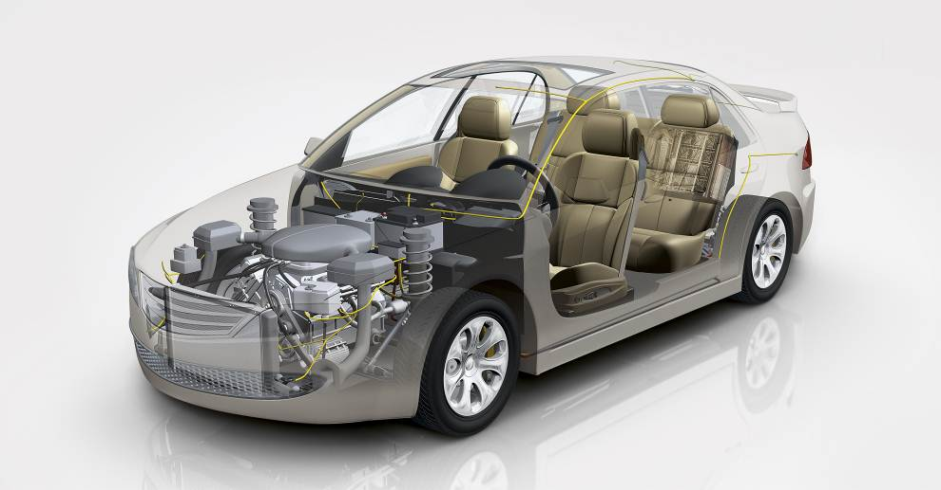

Photo caption:
Using composites the weight of various automotive parts, e.g. roof, doors, or access panels, can be reduced from 25 until 50%.

About Evonik
Evonik, the creative industrial group from Germany, is one of the world leaders in specialty chemicals. Profitable growth and a sustained increase in the value of the company form the heart of Evonik’s corporate strategy. Its activities focus on the key megatrends health, nutrition, resource efficiency and globalization. Evonik benefits specifically from its innovative prowess and integrated technology platforms.

Evonik is active in over 100 countries around the world. In fiscal 2013 more than 33,500 employees generated sales of around €12.7 billion and an operating profit (adjusted EBITDA) of about €2.0 billion.

Disclaimer
In so far as forecasts or expectations are expressed in this press release or where our statements concern the future, these forecasts, expectations or statements may involve known or unknown risks and uncertainties. Actual results or developments may vary, depending on changes in the operating environment. Neither Evonik Industries AG nor its group companies assume an obligation to update the forecasts, expectations or statements contained in this release.

