VESTAMID® HTplus —A High Performance Polymer as a Substitute for Metal
September 14, 2008

Dr. Ursula Keil
Marketing Support High Performance Polymers
Phone +49 2365 49-9878
Fax +49 2365 49-5992
ursula.keil@evonik.com

VESTAMID® HTplus, a new member of Evonik Industries’ VESTAMID® family, has been specially developed as a substitute for metal in classic metal applications. VESTAMID® HTplus is a polyphthalamide (PPA) based semicrystalline material that is stable at high temperatures; it offers an excellent price-performance ratio.

Classic metal parts are increasingly being replaced by parts made of plastic, which have comparable mechanical properties at lower unit cost. In addition to high chemical resistance—as is required, for example, in fuel systems—molded parts made from VESTAMID® HTplus offer high dimensional stability and excellent mechanical properties such as rigidity and tensile strength. VESTAMID® HTplus is therefore ideally suited for use in classic metal applications, for example, as a base material for pump and filter-system housings. In addition to corrosion resistance, reduced component weight, and the resulting reduction—by up to 50 percent—in component costs, the greater design freedom offers several other advantages.

As a thermoplastic material, VESTAMID® HTplus can be economically processed on standard injection molding machines. The finished parts can generally be used without further downstream processing. On the basis of its many years of expertise in the area of extrusion, Evonik's High Performance Polymers Business Line also develops extrusion-grade PPA molding compounds.

In addition to polyphthalamide, Evonik has also been producing polyamide 12, polyamide 612, and polyamide 12 elastomer molding compounds (PEBA) under the VESTAMID® brand name for about 40 years and, more recently, polyamides based on renewable raw materials. Many reputable automotive manufacturers have been using the well-known materials for decades. Evonik is the leading manufacturer of polyamides for multi-layer tubing systems in motor vehicles.

Caption: Due to their excellent mechanical properties, mold parts made from VESTAMID® HTplus can replace metal parts.

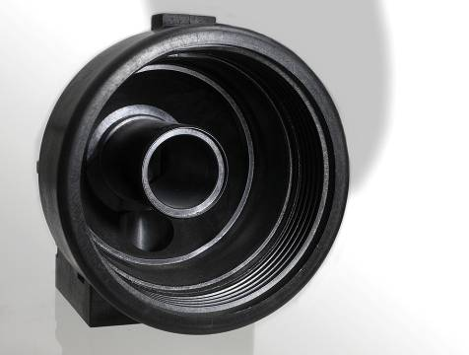

Company information
Evonik Industries is the creative industrial group from Germany which operates in three business areas: Chemicals, Energy and Real Estate. Evonik is a global leader in specialty chemicals, an expert in power generation from hard coal and renewable energies, and one of the largest private residential real estate companies in Germany. Our strengths are creativity, specialization, continuous self-renewal, and reliability. Evonik is active in over 100 countries around the world. In its fiscal year 2007 about 43,000 employees generated sales of about €14.4 billion and an operating profit (EBITDA) of more than €2.2 billion.

Disclaimer
In so far as forecasts or expectations are expressed in this press release or where our statements concern the future, these forecasts, expectations or statements may involve known or unknown risks and uncertainties. Actual results or developments may vary, depending on changes in the operating environment. Neither Evonik Industries AG nor its group companies assume an obligation to update the forecasts, expectations or statements contained in this release.

