VESTAMID® HTplus —A High Performance Polymer As a Substitute for Metal
October 14, 2008

Dr. Ursula Keil
Marketing Support High Performance Polymers
Phone +49 2365 49-9878
Fax +49 2365 49-5992
ursula.keil@evonik.com

- The charge air duct made from VESTAMID® HTplus in the Lotus Exige race car weighs only half as much
- Metal replacement close to the engine is possible

VESTAMID® HTplus, a new member of Evonik Industries’ VESTAMID® family, has been specially developed as a substitute for metal in classic metal applications. VESTAMID® HTplus is a polyphthalamide (PPA) based semicrystalline material that is stable at high temperatures; it offers an excellent price-performance ratio. Its performance was tested for the first time in a Lotus Exige sports car, for which Evonik is the chief sponsor, to examine changes in the material under grueling racing conditions.

The technical innovation of this year's racing season is a charge air duct made of VESTAMID® HTplus. Compared to a charge air duct of metal, the plastic version, 620 mm long and 65 mm in outer diameter, weighs only half as much and optimizes the airflow and engine performance, thanks to its extremely smooth interior walls. Said Olivier Farges, Evonik Director of OEM Marketing for High Performance Polymers: “By using our materials under the tough car racing conditions, we have provided definite proof that our new materials can be used in the immediate vicinity of engines and are resistant to rising temperature demands.” In the charge air duct of charged engines, temperatures can rise up to 170°C, depending on the situation. Farges is also confident that “our material will be more cost-effective in serial production than metal applications.” As a benefit to the environment, the significant weight reduction and smooth surface reduce the fuel consumption of vehicles, which also lowers CO₂ emissions.

In addition to high chemical resistance, molded parts made from VESTAMID® HTplus offer high dimensional stability and excellent mechanical properties such as rigidity and tensile strength. The molding compounds are ideally suited for substitution in conventional metal applications, for example, as a base material for pump and filter systems or as charge air ducts of charged engines and other hot-air ducts in the vicinity of engines.

As a thermoplastic material, VESTAMID® HTplus can be economically processed on standard injection molding machines. The finished parts can generally be used without further downstream processing. On the basis of its many years of expertise in the area of extrusion, Evonik's High Performance Polymers Business Line also develops extrusion-grade PPA molding compounds.

In addition to polyphthalamide, Evonik has also been producing polyamide 12, polyamide 612, and polyamide 12 elastomer molding compounds (PEBA) under the VESTAMID® brand name for about 40 years and, more recently, polyamides based on renewable raw materials. Many reputable manufacturers have been using the well-known materials for decades.

Caption: Successfully tested: Use of Evonik’s new plastic charge air duct in the engine of the Lotus racing car

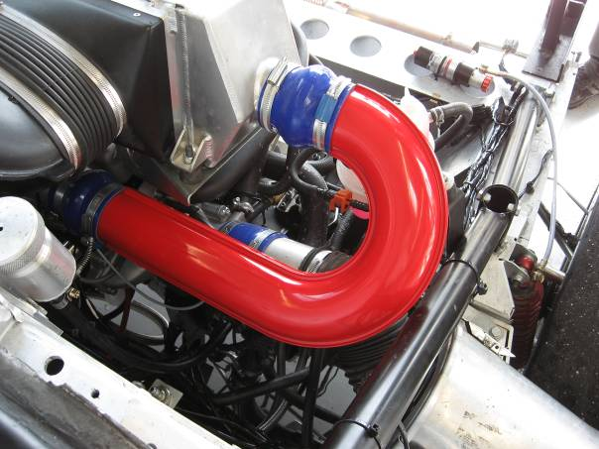

Company information
Evonik Industries is the creative industrial group from Germany which operates in three business areas: Chemicals, Energy and Real Estate. Evonik is a global leader in specialty chemicals, an expert in power generation from hard coal and renewable energies, and one of the largest private residential real estate companies in Germany. Our strengths are creativity, specialization, continuous self-renewal, and reliability. Evonik is active in over 100 countries around the world. In its fiscal year 2007 about 43,000 employees generated sales of about €14.4 billion and an operating profit (EBITDA) of more than €2.2 billion.

Disclaimer
In so far as forecasts or expectations are expressed in this press release or where our statements concern the future, these forecasts, expectations or statements may involve known or unknown risks and uncertainties. Actual results or developments may vary, depending on changes in the operating environment. Neither Evonik Industries AG nor its group companies assume an obligation to update the forecasts, expectations or statements contained in this release.

