Light, Flexible and Stable—Irreconcilable?
October 14, 2008

Dr. Ursula Keil
Marketing Support High Performance Polymers
Phone +49 2365 49-9878
Fax +49 2365 49-5992
ursula.keil@evonik.com

VESTAMID® in High-Quality Sports Shoes

- Soles made from polyetherblockamides (PEBA) feature a high resilience that is virtually unaffected by temperature.
- Because its low density makes VESTAMID® E extremely light, the sprinter saves energy.

Because sports shoes have to be as tough as the athletes who keep raising the bar on performance, Evonik constantly works with producers and sports equipment manufacturers to improve its polyamide 12-based VESTAMID® compounds, which are used in high-quality sports shoe soles. The company’s latest success is the shock-absorbing sole of a running and basketball shoe.

In professional sports, plastic is one of the most sought-after materials because it offers the best combination of low weight, stability, strength, rigidity, and elasticity. Running and basketball shoes, for example, have to provide optimal support for the muscles, bones, and ligaments in the foot. They must cushion hard strikes, stabilize the foot, and hold up under extreme stress. Here, the sole material plays a decisive role. During a 10-kilometer run, for example, each foot lands about 4,300 times at a force of about two to three times the body weight—six times the body weight if you are running downhill. The sole material should prevent the functional and shock-absorbing elements from being compromised over time and losing their effectiveness. The material must neither crack nor break in a 90° bending test for 200,000 cycles at -10° C.

VESTAMID® E polyamide 12 elastomers is able to achieve this profile of characteristics. As polyether block amides (PEBA) composed of hard polyamide 12 segments and soft polyether segments, they combine flexibility and stability. The polyamide 12 segments ensure dimensional accuracy, impact strength, and notched impact strength, even in cold temperatures, and good chemical resistance. The polyether segments guarantee good resilience so that shoe soles made from the material absorb impact well and protect the joints. This resilience, or the minimal loss of energy when the soles are bent, is virtually unaffected by temperature, an important feature that distinguishes this material from a TPU or copolyester material. Because its low density of nearly 1 makes VESTAMID® E extremely light, the weight carried by a 100-meter sprinter is reduced by about 1 kilogram compared to a material like TPU, which has a density of 1.2 g/cm³. This saves energy and increases endurance.

Evonik has been producing, in addition to polyamide 12 elastomers (PEBA), polyamide 12 and 612 compounds for about 40 years, and now also produces polyamides based on renewables and polyphthalamide. Well-known manufacturers have been using these materials for decades.

Figure caption: The translucent intermediate sole made of VESTAMID® E, which acts as a shock absorber in the running shoe, supports the runner with its low weight and high energy return.

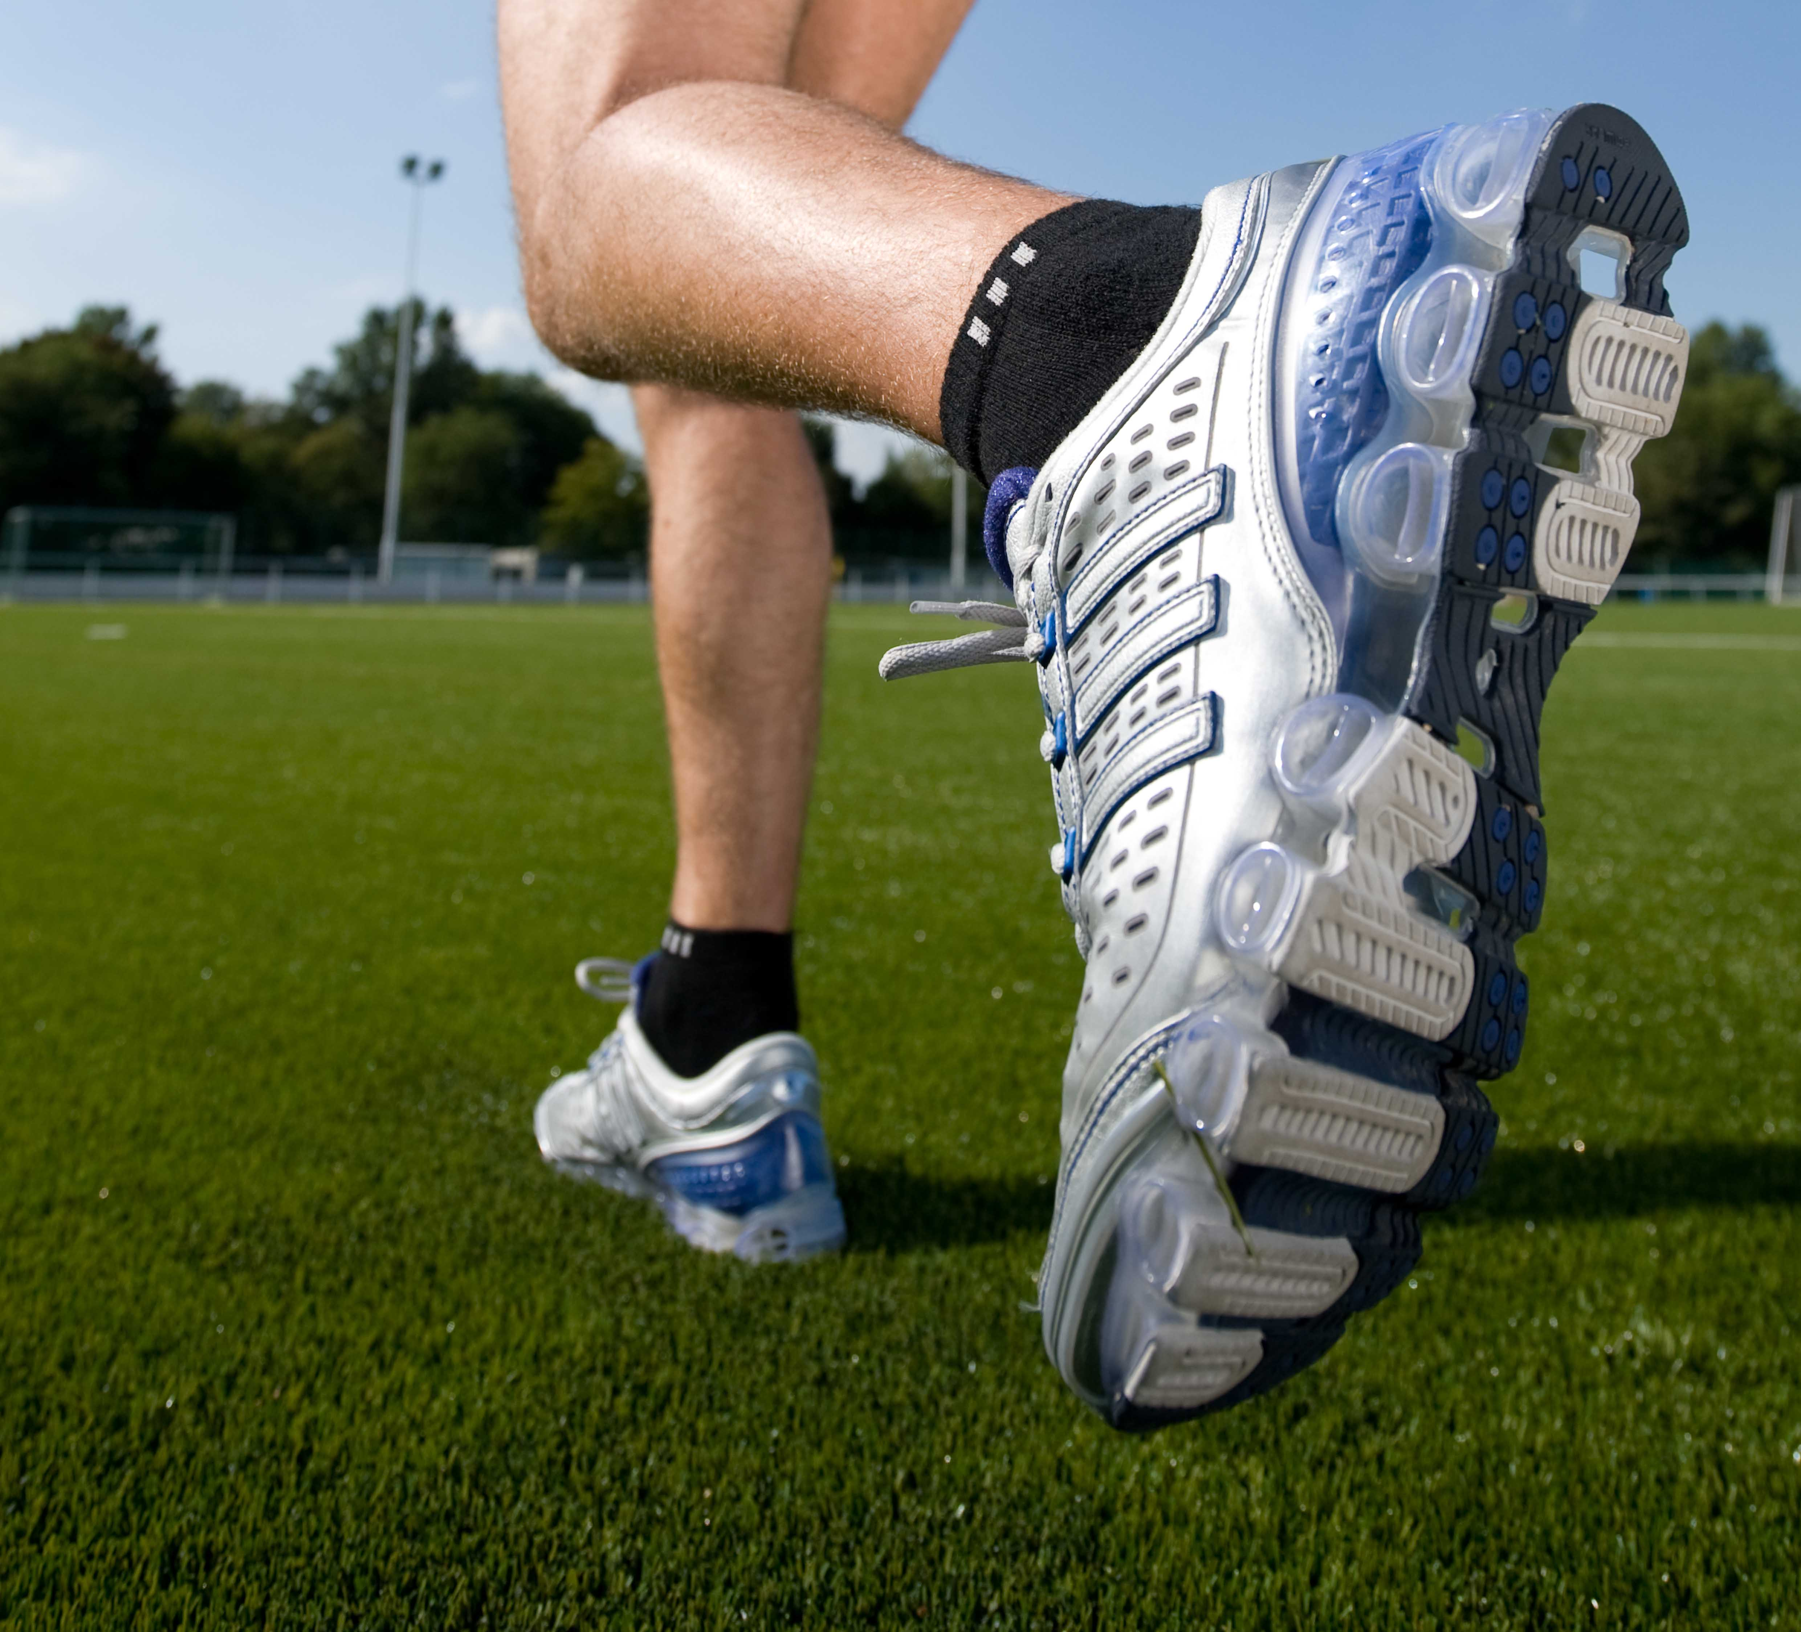

Company information
Evonik Industries is the creative industrial group from Germany which operates in three business areas: Chemicals, Energy and Real Estate. Evonik is a global leader in specialty chemicals, an expert in power generation from hard coal and renewable energies, and one of the largest private residential real estate companies in Germany. Our strengths are creativity, specialization, continuous self-renewal, and reliability. Evonik is active in over 100 countries around the world. In its fiscal year 2007 about 43,000 employees generated sales of about €14.4 billion and an operating profit (EBITDA) of more than €2.2 billion.

Disclaimer
In so far as forecasts or expectations are expressed in this press release or where our statements concern the future, these forecasts, expectations or statements may involve known or unknown risks and uncertainties. Actual results or developments may vary, depending on changes in the operating environment. Neither Evonik Industries AG nor its group companies assume an obligation to update the forecasts, expectations or statements contained in this release.

