Evonik’s VESTAMID PA 12 Set to Revolutionize Natural Gas Distribution and Transmission Lines
September 14, 2009

Dr. Ursula Keil
Marketing Support High Performance Polymers
Phone +49 2365-49-9878
Fax +49 2365-49-5992
ursula.keil@evonik.com

Innovative Product Less Expensive to Install; Easier to Maintain

A new high performance thermoplastic polyamide (PA) pipe that is less expensive to install and easier to maintain than traditional steel pipe has been introduced for the first time in North America.

VESTAMID® LX9030 offers exceptional performance for high-pressure applications which helps gas companies effectively design their underground infrastructure without sacrificing flow capacity. Researchers estimate that PA 12 pipe has significant labor and installation savings over steel.

“PA 12 is an excellent alternative to steel pipe in high-pressure applications up to 18 bars for gas distribution lines,” said Dennis Jarnecke, program manager at Gas Technology Institute (GTI), a research, development and training organization in USA serving energy and environmental markets. “It has been used as fuel lines in cars and for air brake tubing in trucks. Now we see great potential for its use in gas delivery systems.”

Officials at Energy West, a Montana-based (USA) gas utility and energy supplier that is laying three miles (about 4.8 km) of VESTAMID® PA 12 pipe for a natural gas distribution system along Interstate 15 frontage roads outside Great Falls, agree. They are home to the first installation of VESTAMID® PA 12 gas pipe in an established public right of way in the United States.

“There are numerous benefits to utilizing PA 12 pipe,” said Ed Kacer, general manager of Energy West. “The material is lightweight and allows for faster construction than steel, while maintaining higher volumes associated with higher pressures. Installation can be accomplished using a smaller construction crew, saving time and money."

In addition, Kacer said, very little initial investment is required for construction teams because the same equipment and processes are used when installing VESTAMID® PA 12 pipe as other plastic pipe. “Today, it’s getting harder to find qualified welders and many utilities contract their welding,” he explains. “We used our existing plastic fusion equipment and the fusions looked as good as a weld. Working with PA 12 was a very positive experience."

To meet the needs of Energy West, Evonik—working jointly with GTI— coordinated a system of VESTAMID® PA 12 straight and coiled pipes and fittings. Extruded in diameters ranging from 32 to 160 mm, VESTAMID® PA 12 pipes can be manufactured as straight pipe and on coils, depending on the diameter and wall thickness. This flexibility in length— particularly for long stretches of installation—saves money by reducing time spent fusing pipe ends together.

Equipment used in the installation of both straight and coil pipe did not require any modification. The heat fusion process for joining two ends of VESTAMID® PA 12 is easier and faster than connecting steel pipes benefiting the bottom line.

Compliance with pipeline integrity regulations is also more cost-effective. “Traditional steel pipe must adhere to corrosion control and cathode protection requirements which add to a company’s expense,” says Jarnecke. “PA12 is corrosion resistant and has labor and installation savings over steel.”

Federal and State pipeline safety officials, including representatives from the U.S. Department of Transportation, were in attendance in Great Falls to observe the installation, which went according to plans.

More importantly, said Andreas Dowe, Evonik’s Market Development Manager for oil and gas applications, VESTAMID® PA 12 provides users with a comparable alternative to steel pipe for distribution of natural gas. “We believe this innovative material will revolutionize the gas transportation industry in the United States”, he says. “It’s less expensive to install, easier to handle, and maintenance over the long term is less than traditional steel pipe.” And he completes: “We are sure that the benefits will prevail also in other regions worldwide.”

In research performed by GTI and sponsored by Operations Technology Development, NFP (OTD), PA 12 has been evaluated for use as gas-distribution piping in North America, and technical support necessary to obtain regulatory approval for its use in the U.S. was developed. Extensive testing of materials resulted in a comprehensive database of the physical properties of PA 12 pipe and demonstrated conformity to ASTM standards.

For more information please contact Andreas Dowe at + 49 2365 49-7369, e-mail andreas.dowe@evonik.com

Figure captions:
VESTAMID® PA 12 pipe coils reduce labor and installation costs.

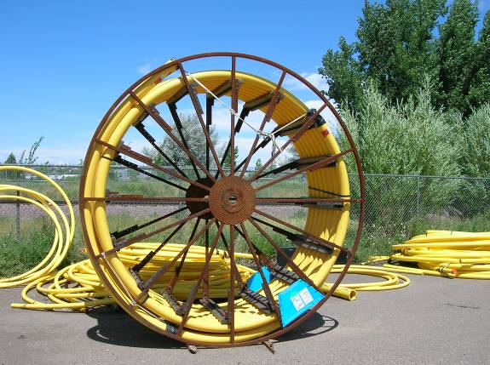

VESTAMID® PA 12 pipe ends are joined using a heat fusion process that is easier and faster than connecting steel pipes, benefiting the bottom line.
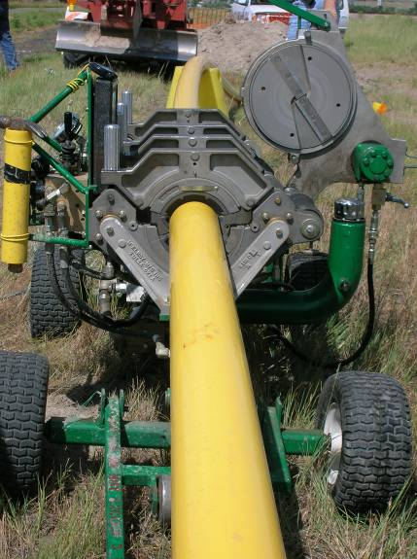

VESTAMID® PA 12 pipe does not require long term corrosion control measures.

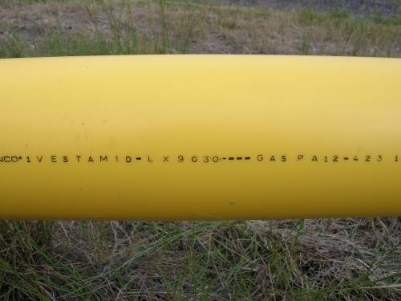

Company information
Evonik Industries is the creative industrial group from Germany which operates in three business areas: Chemicals, Energy and Real Estate. Evonik is a global leader in specialty chemicals, an expert in power generation from hard coal and renewable energies, and one of the largest private residential real estate companies in Germany. Our strengths are creativity, specialization, continuous self-renewal, and reliability. Evonik is active in over 100 countries around the world. In its fiscal year 2008 about 41,000 employees generated sales of about €15.9 billion and an operating profit (EBITDA) of about €2.2 billion.

Disclaimer

In so far as forecasts or expectations are expressed in this press release or where our statements concern the future, these forecasts, expectations or statements may involve known or unknown risks and uncertainties. Actual results or developments may vary, depending on changes in the operating environment. Neither Evonik Industries AG nor its group companies assume an obligation to update the forecasts, expectations or statements contained in this release.

