VESTAMID® for Light, Multi-Layer Cooling Line Systems
March 17, 2010

Dr. Ursula Keil
Marketing Support
Phone +49 2365 49-9878
Fax +49 2365 49-809878
ursula.keil@evonik.com

Cooling line systems made of plastic materials offer many advantages over conventional metal systems or elastomer hoses. Evonik has developed multi-layer tubing systems (MLT) for this application on the basis of VESTAMID® already used by well-known producers.

The systems of the 8000 series, which have diameters up to 30 mm and wall thicknesses ranging from 1 to 1.5 mm, consist of three layers. A polypropylene suitable for the coolant tube application forms the inner layer. On top of this sits an adhesion-promoting layer, followed by an outer layer made of the high-grade specialty polyamide VESTAMID®. Because of a modification carried out at the molecular level, the compound for the MLT 8000.3 provides higher flexibility without the need to add a plasticizer. The MLT 8000.1, on the other hand, features higher bursting strength, especially at high temperatures. The user can thus choose a system that matches his or her requirements.

Compared to conventional metal systems or elastomer hoses, the coolant line systems of the 8000 series offer the following advantages: They are lighter and thinner because of their strength, and easier to thermoform. In contrast to metal lines, they are not susceptible to corrosion and resist vibration cracking. They are easily and quickly joined by means of quick connectors, making them more economical than both conventional systems. Compared to elastomer hoses, the outer polyamide layer also provides low-temperature impact strength, stone impact resistance, and chemical resistance. The lines withstand brief external temperature loads exceeding 150°C, as occur close to the engine, and have high heat-aging resistance and good bursting strength. The inner polyolefin layer also ensures resistance against the ethylene glycol-water mixtures used as coolants, even at temperatures as high as 135°C.

Evonik has been producing polyamide 12, polyamide 612, and polyamide 12 elastomer molding compounds (PEBA) under the VESTAMID® brand name for about 40 years and, more recently, polyamides based on renewable raw materials and polypthalamide. Leading automotive manufacturers have been using the well-known materials for decades. Evonik is the leading manufacturer of polyamides for multi-layer tubing systems in motor vehicles.

Caption:

Practical test of a MLT 8000.3 in the Lotus Exige racing car: The line installed was some 40 percent lighter than the original line.

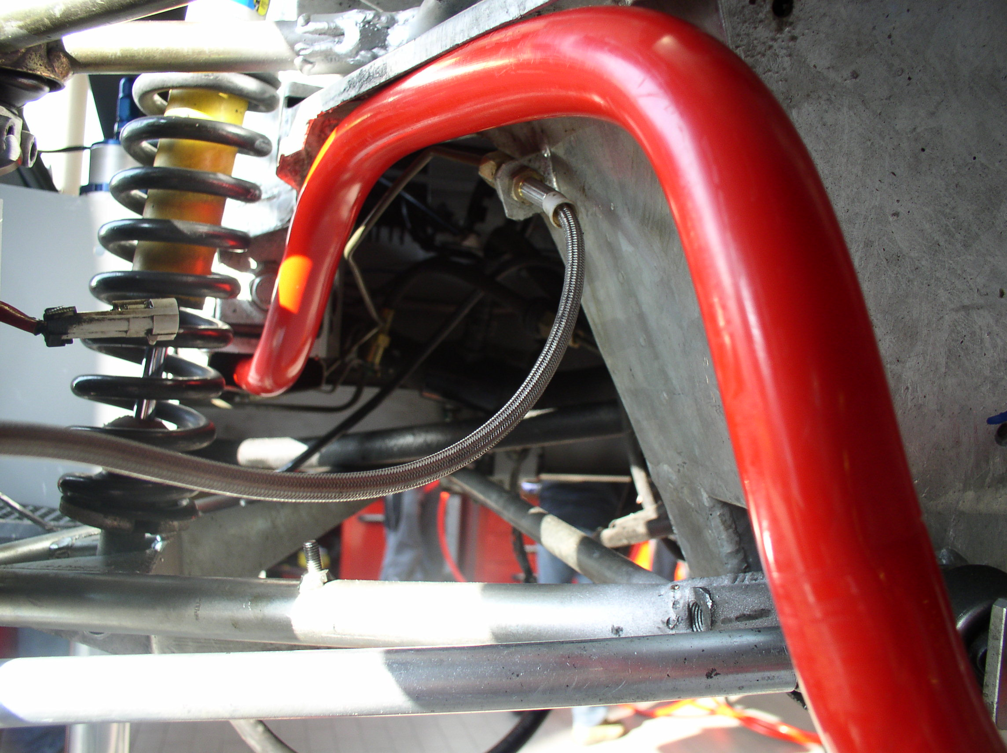

Company information
Evonik Industries is the creative industrial group from Germany which operates in three business areas: Chemicals, Energy and Real Estate. Evonik is a global leader in specialty chemicals, an expert in power generation from hard coal and renewable energies, and one of the largest private residential real estate companies in Germany. Our strengths are creativity, specialization, continuous self-renewal, and reliability. Evonik is active in over 100 countries around the world. In its fiscal year 2008 about 41,000 employees generated sales of about €15.9 billion and an operating profit (EBITDA) of about €2.2 billion.

Disclaimer

In so far as forecasts or expectations are expressed in this press release or where our statements concern the future, these forecasts, expectations or statements may involve known or unknown risks and uncertainties. Actual results or developments may vary, depending on changes in the operating environment. Neither Evonik Industries AG nor its group companies assume an obligation to update the forecasts, expectations or statements contained in this release.

