VESTAMID® HTplus: Evonik now also offers polyphthalamide for composites
June 28, 2010

Dr. Ursula Keil
Marketing Support
Phone +49 2365 49-9878
Fax +49 2365 49-809878
ursula.keil@evonik.com

In the production of composite parts, the use of thermoplastic matrices, as opposed to conventional thermosetting matrices, leads to signifycantly reduced cycle times. For this process, Evonik Industries of Essen, Germany, now offers the polyphthalamide VESTAMID® HTplus as powder, granulate, or film.

Polyphthalamide (PPA) is known for its outstanding performance at high temperatures with excellent mechanical properties. As a matrix for composites Evonik has developed a PA10T-based copolyamide of very low viscosity, which ensures excellent fiber impregnation. It has lower water absorption, and therefore better dimensional and hydrolytic stability, than PA6T. With a glass transition temperature of 125°C and a processing window around 300°C, VESTAMID® HTplus is an ideal high-temperature polymer for composite parts with carbon, glass, or aramid fibers, which are used in the aviation and automotive sectors. These can be stored indefinitely at room temperature; they absorb less moisture than conventional parts with thermosetting matrices, are more easily bonded by thermowelding, and have significantly higher impact resistance. They are particularly suitable for medium- and large-scale production.

The material is available in the form of granules, VESTAMID® HTplus C2000 nc, and as a powder of mean particle size 50 µm, VESTAMID® HTplus C2505 nc. Should you wish to produce composite parts from a film, we can also supply a suitable film of corresponding thickness.

Extensive PPA product range

The complete portfolio of VESTAMID® HTplus covers, in addition to the products for composites, PA6T molding compounds for injection molding applications in the areas of metal substitution and flame retardant systems, granulates for filament production, and the VESTAMID® HTplus R product series. This last comprises specially modified molding compounds that can be bonded to various rubbers without the need for adhesion promoters. The PA10T VESTAMID® M3000 series is based to the extent of 50 percent on renewable raw materials. It is available with glass fiber contents between 30 and 60 percent, and the PA6T series with glass fiber reinforcement between 15 and 60 percent.

Composites expertise pooled

In addition to polyphthalamide, Evonik offers in PEEK VESTAKEEP® and the polyamide 12 VESTAMID® L two further materials for thermoplastic composites. The company has combined information on these and on its wide range of other products for production of composite parts, such as crosslinkers, additives, and ROHACELL® rigid foam, in a single brochure. This is available to producers of prepregs and composite parts at www.evonik.com/composites.

Figure caption:
An easy flowing PA10T powder, VESTAMID® HTplus C2505nc, forms high-temperature resistant composites with carbon, glass, or aramid fibers.

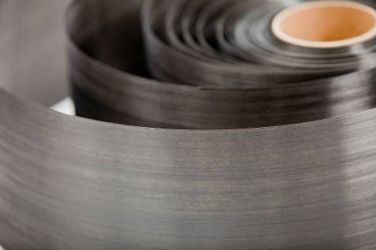

About Evonik
Evonik Industries is the creative industrial group from Germany. In our core business of specialty chemicals, we are a global leader. In addition, Evonik is an expert in power generation from hard coal and renewable energies, and one of the largest private residential real estate companies in Germany. Our company’s performance is shaped by creativity, specialization, continuous self-renewal, and reliability.

Evonik is active in over 100 countries around the world. In its fiscal year 2009 about 39,000 employees generated sales of about €13.1 billion and an operating profit (EBITDA) of about €2.0 billion.

Disclaimer
In so far as forecasts or expectations are expressed in this press release or where our statements concern the future, these forecasts, expectations or statements may involve known or unknown risks and uncertainties. Actual results or developments may vary, depending on changes in the operating environment. Neither Evonik Industries AG nor its group companies assume an obligation to update the forecasts, expectations or statements contained in this release.

