Geothermal Energy Used Even More Efficiently.
October 27, 2010

Dr. Ursula Keil
Marketing Support High Performance Polymers
Phone +49 2365 49-9878
Fax +49 2365 49-809878
ursula.keil@evonik.com

Direct Evaporation Technology with VESTAMID® Polyamide 12 Pipes

Geothermal energy is the most efficient form of heating. It generates 45% less CO₂ than oil-based heating and 33% less than gas. What is more, the new direct heat exchanger technology using propane increases the efficiency of this heating system by a further 10% as no brine needs to be pumped. Essen, Germany-based Evonik Industries delivers the plastic for the tubes required for this technology, which are driven some 100 meters deep into the ground. The material used is VESTAMID®, a polyamide 12 that provides a high barrier to permeation from propane which, unlike steel, can be processed from the reel and does not require corrosion protection.

The conventional process for generating geothermal energy uses a water-glycol brine for the heat exchange that is pumped using polyethylene tubes. The new direct heat exchanger process instead uses the refrigerant R290 (propane), which is available in the tubes as a gas and a liquid during the two phases. Because of the difference in temperature—at depths of 100 meters it is around 4°C to 5°C warmer than close to the surface—the propane circulates exclusively due to the physical effect of the evaporation and condensation. This makes a pump unnecessary, which saves energy and consequently increases the heat generation efficiency by 10%. Polyethylene tubes cannot be used for this method, however, as they are permeable to propane gas.

The alternatives are steel pipes, or pipes made of polyamide 12. The advantage of the latter is that they do not corrode and can be wound on rolls so that no on-site welding is required when the pipes are being laid. Tubes made of VESTAMID® modified especially for this application also have a rough inner surface that is indispensible for the development of falling film in the heat exchanger.

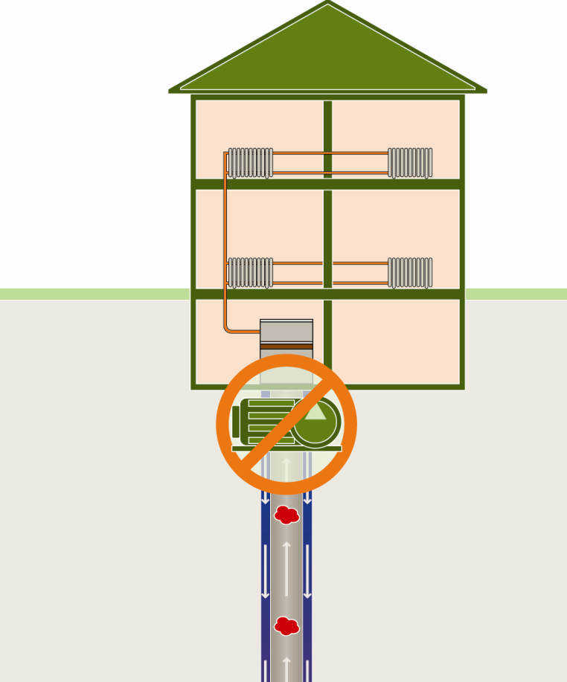
Caption
Direct heat exchanger
technology using VESTAMID® polyamide 12 tubes improves the efficiency of geothermal energy production by a further 10%.

Exceptional solutions in plastics are no exception for us
Working together with its customers and partners, Evonik develops products and system solutions for and with plastics. We thus have a range of services that satisfies market and application requirements.

Evonik is present in all major growth markets around the globe. Its customized products and solutions include raw materials, sophisticated additives and paints, engineering plastics, high-performance polymers, and semi-finished products. They are virtually exactly what is needed for tomorrow’s efficient, sustainable, and environmentally friendly ideas.

About Evonik
Evonik Industries is the creative industrial group from Germany. In our core business of specialty chemicals, we are a global leader. In addition, Evonik is an expert in power generation from hard coal and renewable energies, and one of the largest private residential real estate companies in Germany. Our company’s performance is shaped by creativity, specialization, continuous self-renewal, and reliability.

Evonik is active in over 100 countries around the world. In its fiscal year 2009 about 39,000 employees generated sales of about €13.1 billion and an operating profit (EBITDA) of about €2.0 billion.

Disclaimer
In so far as forecasts or expectations are expressed in this press release or where our statements concern the future, these forecasts, expectations or statements may involve known or unknown risks and uncertainties. Actual results or developments may vary, depending on changes in the operating environment. Neither Evonik Industries AG nor its group companies assume an obligation to update the forecasts, expectations or statements contained in this release.

