New liner technology offers up to 50 percent cost savings
May 2, 2011

Thomas Lange
Communications
High Performance Polymers
Phone +49 2365 49-9227
Fax +49 2365 49-809227
thomas.lange2@evonik.com

Evonik and Swagelining Limited develop alternative technology for deep-sea pipelines for oil production

The joint development of a lining solution by Evonik Industries (Essen, Germany) and Swagelining Limited (Glasgow, UK) is still in its infancy—but its potential is huge. Instead of the corrosion resistant alloy pipes currently used for many offshore oil production flowlines, the two companies are now developing a completely different concept: a combination of established liner technology from Swagelining and the custom-tailored VESTAMID® polyamide 12 from Evonik. This technology, based on the well proven concept of PE lining, which has been used successfully for many years to protect water-injection lines worldwide, is now being developed for hydrocarbon service to 100 degrees c.

Compared to corrosion resistant alloy pipes currently used for hydrocarbon transportation, carbon steel pipes offer significant cost-benefits and are far more readily available but are also far more susceptible to corrosion from aggressive products. Carbon steel pipes with liners constructed of VESTAMID®, on the other hand, are protected against internal corrosion and also offer an enormous weight and price advantage.

In the current project phase of development, VESTAMID® is being integrated with Swagelining’s proven liner installation technology to provide a close fitting fully protected pipeline system. Operators of subsea pipelines are invited to contact us for further information on this project.

With VESTAMID®, Evonik is the worldwide leading producer of polyamide 12 for flexible pipes for subsea oil production.

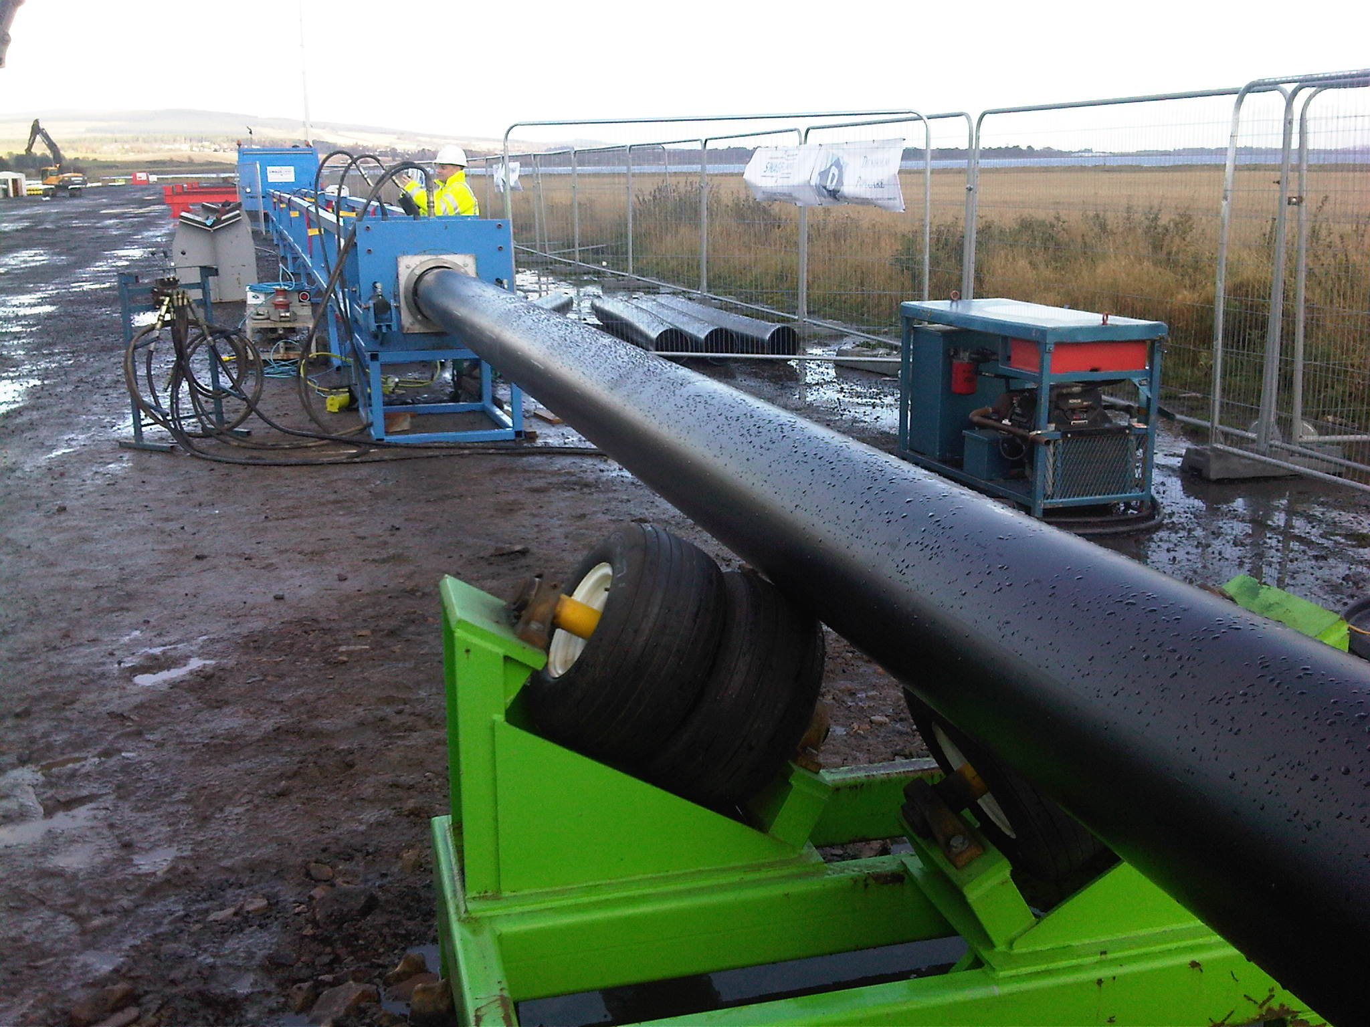Image Caption: Installation of a polymer liner by the SwageliningTM-Technology.

About Evonik
Evonik is the creative industrial group from Germany. In our core business of specialty chemicals, we are a global leader. In addition, it has energy and residential real estate operations. Our performance is shaped by creativity, specialization, reliability and continuous self-renewal.
Evonik is active in over 100 countries around the world. In fiscal 2010 more than 34,000 employees generated sales of around €13.3 billion and an operating profit (EBIDA) of about €2.4 billion.

About Swagelining Limited
Using technologies developed by British Gas to rehabilitate existing buried pipelines, Swagelining Limited specialises in control and prevention of internal corrosion in pipelines and risers. Swagelining™ technology made its debut in reeled water Injection pipelines in 1995 West of Shetland. Prior to this, the technology was used extensively around the world in many challenging applications and environments. Today, Swagelining Limited is providing an Integrated Lining System for the pipeline industry, combining proven technology with project management for polymer liner system design, specification, procurement and construction.

Disclaimer
In so far as forecasts or expectations are expressed in this press release or where our statements concern the future, these forecasts, expectations or statements may involve known or unknown risks and uncertainties. Actual results or developments may vary, depending on changes in the operating environment. Neither Evonik Industries AG nor its group companies assume an obligation to update the forecasts, expectations or statements contained in this release.

