More than 400 offshore pipes with VESTAMID® NRG
February 3, 2012

Thomas Lange
Manager Communications
High Performance Polymers
Phone +49 2365-49-9227
Fax +49 2365-49-80227
thomas.lange2@evonik.com

VESTAMID® NRG 1001, a high-performance polymer, can already be found in a total of over 800 kilometers of pipeline. The polyamide 12 made by Evonik Industries has gone into the making of more than 400 unbonded flexible pipes to service the oil production industry. Oil companies have been using these pipes in their offshore projects for years now.

What has made the polyamide-12 molding compound so popular are its superior properties over those of other polyamides used as barrier layers in flexible pipes. Together with Wellstream International Limited, Evonik conducted intensive testing to demonstrate compliance with the international norms API 17J for flexible risers and ISO 13628-2. The tests praised the creep performance, ductility, thermal expansion, methanol compatibility, and hydrolysis resistance.

The molding compound has since been used commercially for the manufacture of flexible pipes. Specially developed VESTAMID® NRG combines its technical advantages with extraordinarily consistent product quality, which ensures outstanding processability and thus reduces setup times, scrap and the risk of extrusion faults.

The new name, VESTAMID® NRG, stands for a whole range of polyamides—employed, most notably, in the energy sector. And that range includes VESTAMID® LX9020, a product which has been well established on the market for years.

For decades now, Evonik has been a leader in the development and marketing of high-grade polyamide compounds for line systems in motor vehicles. This high degree of expertise in the development of extrusion compounds has now been carried over to molding compounds for the thick-walled piping systems which, thanks to their advantages over existing systems, are increasingly coming into use in the oil and gas industries.
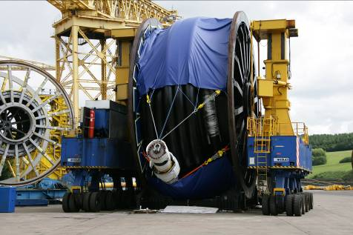
Source: Wellstream

Bildunterschrift
It is easy to see, even at first glance, just how flexible these production pipes are.

Company information
Evonik, the creative industrial group from Germany, is one of the world leaders
in specialty chemicals. Its activities focus on the key megatrends health, nutrition, resource efficiency and globalization. In 2010 about 80 percent of the Group’s chemicals sales came from activities where it ranks among the market leaders. Evonik benefits specifically from its innovative prowess and integrated technology platforms.
Evonik is active in over 100 countries around the world. In fiscal 2010 more than 34,000 employees generated sales of around €13.3 billion and an operating profit (EBITDA) of about €2.4 billion.

Disclaimer
In so far as forecasts or expectations are expressed in this press release or where our statements concern the future, these forecasts, expectations or statements may involve known or unknown risks and uncertainties. Actual results or developments may vary, depending on changes in the operating environment. Neither Evonik Industries AG nor its group companies assume an obligation to update the forecasts, expectations or statements contained in this release.

