No strings attached:
August 14, 2012
Contact person economic press
Thomas Lange
Communications
High Performance Polymers
Phone +49 2365 49-9227
Fax +49 2365 49-809227
thomas.lange2@evonik.com
Evonik Industries AG
Rellinghauser Strasse 1-11
45128 Essen
Germany
www.evonik.com
www.vestamid.de

Chairman of the Supervisory Board
Wilhelm Bonse-Geuking
Executive Board
Dr. Klaus Engel, Chairman
Dr. Wolfgang Colberg,
Dr. Thomas Haeberle, Thomas Wessel,
Patrik Wohlhauser, Dr. Dahai Yu

Registered Office: Essen
Register Court: Essen Local Court
Commercial Registry B 19474
VAT ID no. DE 81116003

Rayon fiber reinforced bio-based polyamides offer
high bio-content and a good reinforcement potential

- High bio-content of between 67 and 100 percent
- CO₂ savings of 57 percent

Evonik Industries has developed and launched on the market a novel combination of bio-based high-performance polyamides and bio-based high-performance fibers.

Reinforcing fibers, particularly chopped fiberglass, are often mixed into a plastic to improve its mechanical properties. But in the case of bio-based polymers this means that the bio-content is lowered, reducing the ecological advantage. The use of natural fibers, on the other hand, has so far resulted in significant deterioration of reinforcing potential, and also an unpleasant odor in the end product. VESTAMID® Terra with rayon fibers retains the high bio-content—along with excellent reinforcing potential.

Two polyamide grades of the VESTAMID® Terra product family form the polymer matrix: Terra HS and Terra DS. These polyamides are fully or partially obtained from the castor oil plant. Commercially available chopped rayon fibers form the reinforcing fiber substrate. Rayon is also known as man-made cellulose or technically as viscose fibers. These fibers are obtained entirely from wood residues (dissolving pulp), and are therefore also based on renewable raw materials. The overall bio-content is thus high, lying between 67 and 100 percent.

Compared with fiberglass reinforced systems, the combination of viscose fibers and polymer matrix offers a significantly improved carbon balance. As an example, CO₂ savings for a viscose fiber system of PA1010 with a fiber content of 30% are 57 percent higher than for a 30% glass fiber reinforced PA66.

Additionally, viscose reinforcing fibers have a significantly lower density than mineral fibers: Depending on fiber content, bio-polyamides reinforced with viscose fibers offer a weight reduction of up to 10%, for the same reinforcing performance.

"With this product development, we want to further support the unrestricted expansion of bio-based products in technically demanding applications for our customers," says Dr. Benjamin Brehmer, Business Manager Biopolymers at Evonik.

Evonik offers VESTAMID® Terra grades of varying fiber content, to satisfy a wide range of mechanical demands.

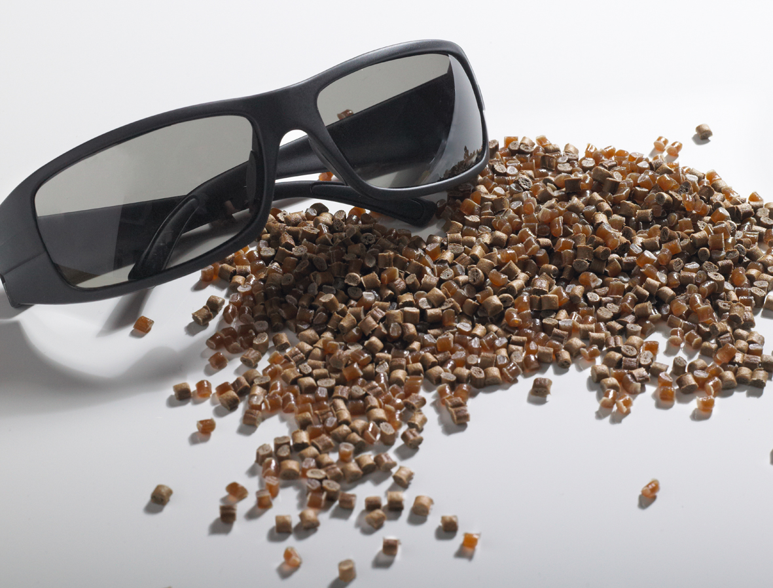
Image caption

High-performance and bio-based—the VESTAMID® Terra product family

Company information
Evonik, the creative industrial group from Germany, is one of the world leaders in specialty chemicals. Profitable growth and a sustained increase in the value of the company form the heart of Evonik’s corporate strategy. Its activities focus on the key megatrends health, nutrition, resource efficiency, and globalization. Evonik benefits specifically from its innovative prowess and integrated technology platforms.
Evonik is active in over 100 countries around the world. In fiscal 2011 more than 33,000 employees generated sales of around €14.5 billion and an operating profit (adjusted EBITDA) of about €2.8 billion.

Disclaimer
In so far as forecasts or expectations are expressed in this press release or where our statements concern the future, these forecasts, expectations or statements may involve known or unknown risks and uncertainties. Actual results or developments may vary, depending on changes in the operating environment. Neither Evonik Industries AG nor its group companies assume an obligation to update the forecasts, expectations or statements contained in this release.

