Have athletes and materials reached their limit?
October 14, 2014

Dr. Ursula Keil
Contact specialized press
High Performance Polymers
Phone +49 2365-49-9878
Fax +49 2365-49-809878
ursula.keil@evonik.com

Evonik Industries AG
Rellinghauser Straße 1-11
45128 Essen
Germany
Phone +49 201 177-01
Fax +49 201 177-3475
www.evonik.com
www.vestamid.com

Chairman of the Supervisory Board
Dr. Werner Müller
Executive Board
Dr. Klaus Engel, Chairman
Christian Kullmann
Thomas Wessel
Patrik Wohlhauser
Dr. Uwe Wolf

Registered Office: Essen
Register Court: Essen Local Court
Commercial Registry B 19474
VAT ID no. DE 811160003
VESTAMID® and DAIAMID® for the next generation of sports shoes

Can a human run 100 meters in 9.29 seconds? Or is 9.48 seconds the theoretical limit? While scientists argue over that, the fastest men in the world are attempting to break Usain Bolt's world record of 9.58 seconds. Aside from their personal performance, the most important sports equipment they will have in this endeavor is their shoes. One such example is the Spike (SONICSPRINT ELITE) shoe from the ASICS Corporation (Headquarters: Kobe, Japan; President CEO: Motoi Oyama), which contains the DAIAMID® polyamide 12 elastomer from Daicel-Evonik in its sole.

Movement and speed are a challenge for material researchers and shoe developers. For this reason, they have worked closely together for years to transform the latest scientific findings into the ideal fit. For many of their new developments in sports-shoe soles, renowned sports manufacturers have long relied on VESTAMID® polyamide 12 molding compounds from Evonik Industries, Essen, as well as on DAIAMID® by the joint venture Daicel-Evonik (Headquarters: Tokyo, Japan; President : Andre Noppe), which are ultra-light because of their low density of nearly 1g/cm³.

Energy recovery
Low weight is particularly important in a sports shoe for optimal support of the complex interplay of muscles, bones and ligaments in the foot. In addition, the properties of the sole have to ensure that the transmitted energy is returned as completely as possible to the support by a spring effect. Klaus Hülsmann, Key Account Manager at Evonik for the Sports segment, is convinced that, “When it comes to developing new polymers for the sports sector, it’s crucial to meet the needs of a fast-changing market. This is why we and our partners develop polyamides and plastics systems specifically targeted to each discipline."

VESTAMID® and DAIAMID® grades from polyamide 12 family are firm yet flexible enough that they release much of the energy absorbed when they are deformed back to the runner as an impulse. Because of the excellent mechanical stability of the materials, the shoes can be designed with features that save even more weight, such as soles that do not cover the entire surface or—as in the soles of the ASICS sprint shoe—a superior reinforcing technique. “The combination of rigidity and flexibility this creates gives the shoe the explosiveness a sprinter needs at the starting block”, explains Hiroaki Arita, senior researcher and group leader of Technical Center of Daicel-Evonik.

VESTAMID® and DAIAMID® can be dyed in a variety of brilliant colors. With the proper equipment, they can be laser-welded and laser-marked. They are used in a range of footwear, from ski boots to running shoes and football shoes, and can safely include metal inserts for clip connections for such features as cleats.

Growing use of rubber nubs
Daicel-Evonik is responsible for another development: the R-COMPO® sole is a composite of polyamide 12 and rubber nubs, and has an optimized ratio between excellent grip and low abrasion. The patented plastic-rubber composite technology played a key role in its development. This process involves bonding plastic to rubber so strongly without any additional adhesion promoters that any attempt to destroy the bond is more likely to rip the plastic than the actual binding site. New Balance, Japan, is already using it in several of its running-shoe models.

Development of design and material
Evonik supports its customers not only with material development but also in design development using CAD and form-fill simulations. In material development, the company also increasingly relies on the bio-based molding compounds VESTAMID® Terra, which has a smaller CO₂ footprint than petroleum-based polyamides. Just like conventional molding compounds, their properties can be tailored to future sole developments, whether hard or soft.

We would be happy to provide more detailed information to visitors to our stand (4117, in hall A4) at FAKUMA in Friedrichshafen between October 14 and 18.

Photo captions:
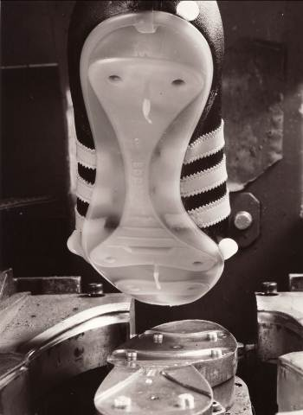
1. The first metric tons of VESTAMID® were delivered 50 years ago, and marked the start of the development of polyamide 12 sports-shoe soles.
Photo: Evonik Archive, 1973

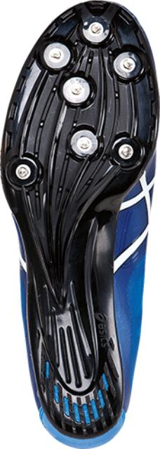
- The ASICS SONICSPRINT ELITE(G402Y) is an ultra-light spike shoe with a glass fiber reinforced sole made from DAIAMID®, which gives the shoe the explosiveness an athlete needs at the starting block when running a sprint.

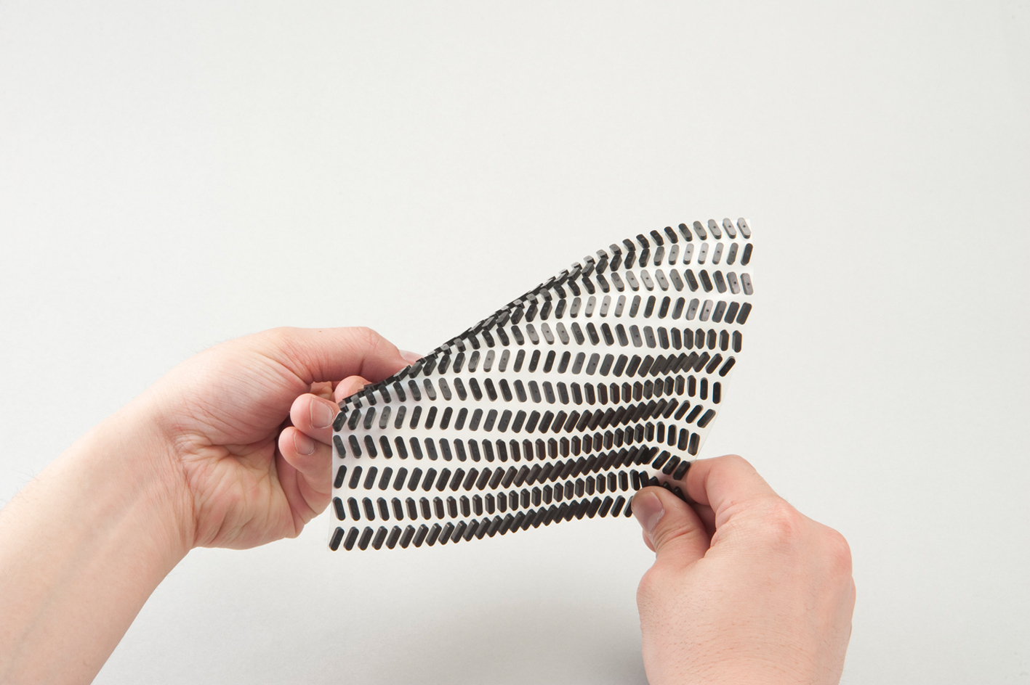
- For an excellent grip, the R-COMPO® sole from Daicel-Evonik contains rubber nubs firmly bonded with the polyamide 12 sole.

About Evonik
Evonik, the creative industrial group from Germany, is one of the world leaders in specialty chemicals. Profitable growth and a sustained increase in the value of the company form the heart of Evonik’s corporate strategy. Its activities focus on the key megatrends health, nutrition, resource efficiency and globalization. Evonik benefits specifically from its innovative prowess and integrated technology platforms.

Evonik is active in over 100 countries around the world. In fiscal 2013 more than 33,500 employees generated sales of around €12.7 billion and an operating profit (adjusted EBITDA) of about €2.0 billion.

About Daicel-Evonik
Daicel-Evonik was established in 1970 as a joint venture of Huls AG (now Evonik Industries), Germany and Daicel Chemical Industries Ltd. (now Daicel Ltd.). Since then, we have developed superior function resin products such as DAIAMID and VESTAMID®, VESTOSINT® (nylon-12 resin), and TROGOMID® (transparent nylon). In recent years we have enriched the variety of the products we deal with such as C8&C12 alicyclic compound, plexiglass (PMMA resin), and VESTAKEEP® (utraheat resistance resin). In order to deliver higher additional value products to our customers, we are always endevouring to improve product quality and strengthen our support structure with new viewpoints and ideas.

About ASICS Corporation
ASICS Corporation is a company of leading design and manufacture of running shoes, as well as, other athletic footwear, apparel and accessories.
The corporate name ASICS was derived from “Anima Sana In Corpore Sano”, meaning “A Sound Mind in a Sound Body” in an old Latin phrase. And it is the fundamental platform on which the brand still stands. The company was founded more than 60 years ago by Kihachiro Onitsuka. For more information, please visit www.asics.com

Disclaimer
In so far as forecasts or expectations are expressed in this press release or where our statements concern the future, these forecasts, expectations or statements may involve known or unknown risks and uncertainties. Actual results or developments may vary, depending on changes in the operating environment. Neither Evonik Industries AG nor its group companies assume an obligation to update the forecasts, expectations or statements contained in this release.

