Cable conduits made from VESTAMID® meet the new, strict railway standard for fire protection
October 14, 2014

Dr. Ursula Keil
Contact specialized press
High Performance Polymers
Phone +49 2365-49-9878
Fax +49 2365-49-809878
ursula.keil@evonik.com

Evonik Industries AG
Rellinghauser Straße 1-11
45128 Essen
Germany
Phone +49 201 177-01
Fax +49 201 177-3475
www.evonik.com
www.rohacell.com

Chairman of the Supervisory Board
Dr. Werner Müller
Executive Board
Dr. Klaus Engel, Chairman
Christian Kullmann
Thomas Wessel
Patrik Wohlhauser
Dr. Uwe Wolf

Registered Office: Essen
Register Court: Essen Local Court
Commercial Registry B 19474
VAT ID no. DE 811160003

A new polyamide 12 VESTAMID® grade from Evonik Industries, Marl (Germany), fulfils the requirements of hazard level 3 (HL3) of the standard EN 45545-2 : 2013 for railway vehicles, which has the most stringent requirements for fire protection. The new, black-colored molding compound for cables and cable conduits can be used in sensitive interiors and also in exterior areas.

The new norm EN 45545-2 : 2013 has been in existence in Europe since August 2013 and prescribes requirements for the fire performance of materials and components used in rail vehicles. It places substantially more stringent requirements on the smoke density and oxygen index, a combination which the plastics used up until now were not able to fulfil. Evonik therefore developed a new VESTAMID® molding compound based on polyamide 12, which meets the required values for both properties. It goes without saying that the smoke toxicity also meets the requirements of the new norm.

The newly developed molding compound has a high dynamic load capacity and high impact strength, even in cold weather, as is typical of VESTAMID® molding compounds. Although it is colored in black, the coloring does not adversely affect the excellent fire-protection properties. Aside from rail vehicles, the extrusion molding compound can be used in all areas that require high levels of fire protection.

Whether it’s for automobiles, electronics, oil production or photovoltaics, Evonik produces a range of VESTAMID® polyamide 12 products with customized properties, which have been constantly adapted to the demands of innovative, high-quality applications for more than 50 years in close cooperation with customers. Find out more about the latest developments at FAKUMA in Friedrichshafen (Germany) from October 14 to 18 in Hall A4, Stand 4117.

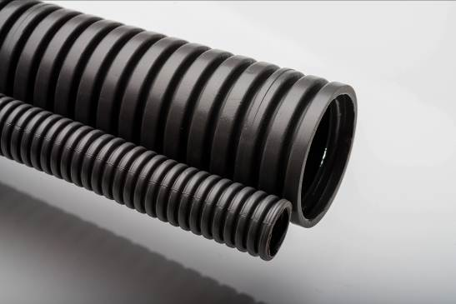

Photo caption:
The new, black VESTAMID® molding compound fulfils the stringent requirements of the new norm for rail vehicles regarding the combination of low smoke density and high oxygen index for interiors and exteriors.

About Evonik
Evonik, the creative industrial group from Germany, is one of the world leaders in specialty chemicals. Profitable growth and a sustained increase in the value of the company form the heart of Evonik’s corporate strategy. Its activities focus on the key megatrends health, nutrition, resource efficiency and globalization. Evonik benefits specifically from its innovative prowess and integrated technology platforms.

Evonik is active in over 100 countries around the world. In fiscal 2013 more than 33,500 employees generated sales of around €12.7 billion and an operating profit (adjusted EBITDA) of about €2.0 billion.

Disclaimer
In so far as forecasts or expectations are expressed in this press release or where our statements concern the future, these forecasts, expectations or statements may involve known or unknown risks and uncertainties. Actual results or developments may vary, depending on changes in the operating environment. Neither Evonik Industries AG nor its group companies assume an obligation to update the forecasts, expectations or statements contained in this release.

