New product: VESTAMID® HTplus M8000 increases the reliability of LED lights and lens modules

The Resource Efficiency Segment of Evonik is launching VESTAMID® HTplus M8000, a new product that was specially developed for high-performance applications in the electrical and electronics industry.

VESTAMID® HTplus M8000 provides the key base ingredient in a compound for making products such as high-performance LEDs highly temperature resistant and light-stable.

Such high-performance LEDs can typically by found in car headlamps, flat screen televisions and even outdoor stadium lightings. In addition, the LED housing must also be light-stable to retain its optical and thermal properties during its service life. Otherwise the housing may turned yellowish due to effects of the UV light and the heat generated by the LEDs. As a result, the color temperature of the LEDs can change, or even failed prematurely.

In another application, VESTAMID® HTplus M8000 enables the compound to provide the mechanical integrity for the moveable lens module units found in the smartphones. This is the limitation of existing lens modules based on LCP (liquid crystal polymer) where the presence of weld lines could led to the breakage of the movable frame. As a result, such moveable lens module units build on VESTAMID® HTplus M8000 based compound allow a higher pixel count design specification and consequently increases the image resolution of the smartphone camera.

Supporting thin-wall applications in the electronics industry

“VESTAMID® HTplus M8000 was specially developed for these extreme specifications,” says Dr. Simon Ting, global business director for high-temperature polymers at Evonik Resource Efficiency GmbH. “Our new product stands out due to its optimum thermal stability, its wide process window, and also its outstanding flowability—properties that are particularly needed in thin-wall applications in the electronics industry.” Furthermore, VESTAMID® HTplus M8000 can withstand temperatures of up to 280 degrees Celsius.

“With the new high-performance polymer we are working hand in hand with our customers, who are faced with the challenge of producing state-of-the-art, high-performing and ever more compact products for the continually growing electronics market,” explains Dr. Ting.

Utilizing renewable raw materials

VESTAMID® HTplus M8000 is partially based on the castor oil plant, a resource which is not used for feeding animals and which is not in competition with food cultivation.

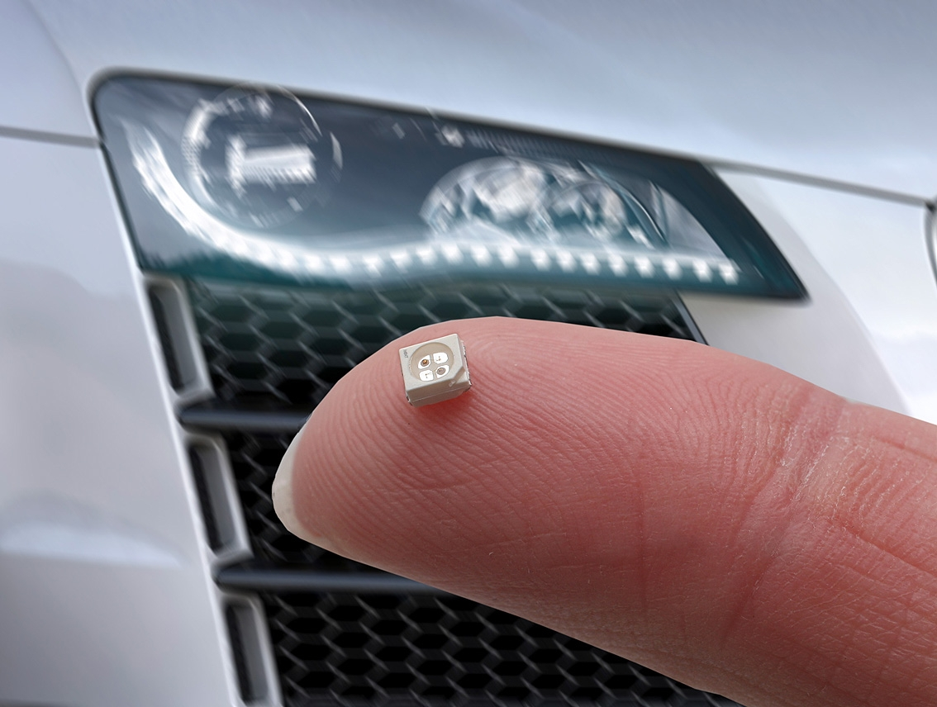

Capture:
High performance LED produced from compound made out of VESTAMID® HTplus M8000.

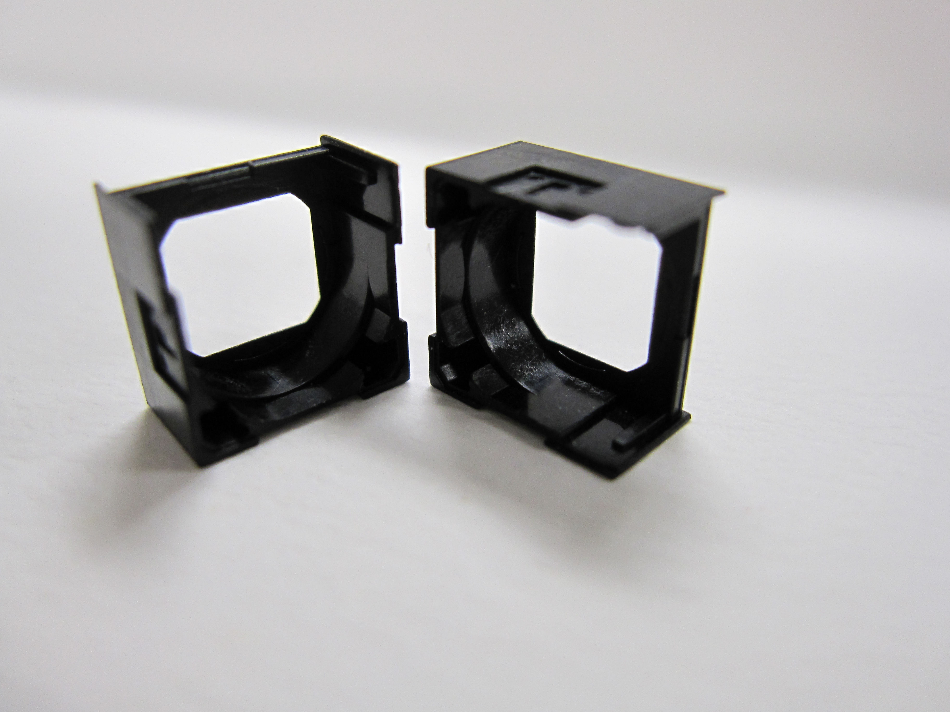

Capture:
High performance movable lens module units produced from compound made out of VESTAMID® HTplus M8000.

Discover more about the high performance polymers from Evonik at our stand 4117 in Hall 4 at FAKUMA in Friedrichshafen, Germany, from October 13 to 17.

About Resource Efficiency
The Resource Efficiency segment is led by Evonik Resource Efficiency GmbH and supplies high performance materials for environmentally friendly as well as energy-efficient systems to the automotive, paints & coatings, adhesives, construction, and many other industries. This segment employed about 7,800 employees, and generated sales of around €4 billion in 2014.

About Evonik
Evonik, the creative industrial group from Germany, is one of the world leaders in specialty chemicals, operating in the Nutrition & Care, Resource Efficiency and Performance Materials segments. The company benefits from its innovative prowess and integrated technology platforms. In 2014 more than 33,000 employees generated sales of around €12.9 billion and an operating profit (adjusted EBITDA) of about €1.9 billion.

Disclaimer
In so far as forecasts or expectations are expressed in this press release or where our statements concern the future, these forecasts, expectations or statements may involve known or unknown risks and uncertainties. Actual results or developments may vary, depending on changes in the operating environment. Neither Evonik Industries AG nor its group companies assume an obligation to update the forecasts, expectations or statements contained in this release.

