February 10, 2016

Specialized Press Contact
Dr. Ursula Keil
High Performance Polymers
Phone +49 2365-49-9878
Fax +49 2365-49-809878
ursula.keil@evonik.com

Evonik Resource Efficiency GmbH
Rellinghauser Strasse 1-11
45128 Essen
Germany
Phone +49 201 177-01
Fax +49 201 177-3475
www.evonik.com

Supervisory Board
Dr. Ralph Sven Kaufmann, Chairman
Management Board
Dr. Claus Rettig, Chairman
Dr. Johannes Ohmer,
Simone Hildmann,
Alexandra Schwarz

Registered Office: Essen
Register Court: Essen Local Court
Commercial Registry B 25783
VAT ID no. DE 815528487
Evonik’s Polyamide 12 Wins European Plastics Innovation Award
- VESTAMID® NRG enables cost-effective installations of natural gas networks and pipelines and reduces their maintenance needs
- Technical Standard GW335-A6 for the material published in December 2015 by the German Technical and Scientific Association for Gas and Water (DVGW)
The Resource Efficiency Segment of the Essen-based Evonik Group received the European Plastics Innovation Award in the “Material Innovation” category for its use of polyamide 12 (PA 12) VESTAMID® NRG in high-pressure gas pipelines. PlasticsEurope, the Association of Plastics Manufacturers in Europe, and the Society of Plastics Engineers (SPE) had organized the joint award for the first time in eight different categories. It recognizes companies that have attracted public attention with particularly innovative developments in plastics technology.
VESTAMID® NRG offers an outstanding property profile for high-pressure pipelines and enables gas utilities to effectively build up their subterranean pipeline networks without any concern about losses in throughput performance. A number of installations, including in the U.S., Brazil, Mexico and Indonesia, have demonstrated that pipes made of PA 12 allow for significant savings in labor and installation cost compared to steel.
In its rationale for the award, the jury, made up of representatives from universities, politics, NGOs and the media, highlighted Evonik’s decade-long intensive research that resulted in gas pipe materials for the high-pressure segment up to 18 bar and their installation, along with the company’s efforts to support the requisite approvals. The most recent step in the safety-relevant authorization of the material is its inclusion in the test specification by the German Association of Gas and Water (DVGW) of December 2015, entitled “Plastic piping systems in gas and water distribution; GW335-A6: Pipes made of PA-U 160 and PA-U 180 and associated fittings and joints.”
“This test specification will pave the way for installations in Germany,” says Markus Hartmann, Head of the Oil & Gas segment, who oversees the Evonik business with VESTAMID® NRG. “Our experiences with installations involving our coordinated system of straight and rolled-up pipes from 32 to 160 mm made of VESTAMID® NRG and the associated fittings have been very good so far. The award will encourage us to further advance this application.” The flexible selection of length–especially over extended installation sections–saves time and cost because fewer welding seams are required. Installers can use the same equipment as for PE pipes. In addition, no anti-corrosive treatment is required and the material enables trenchless installation, which also lowers cost.
VESTAMID® has been used by renowned manufacturers for over 50 years. While the first applications included automotive duct systems, the continuous advancement of the material eventually led to its use in large-volume pipes for oil and gas production and gas distribution.
Captions:
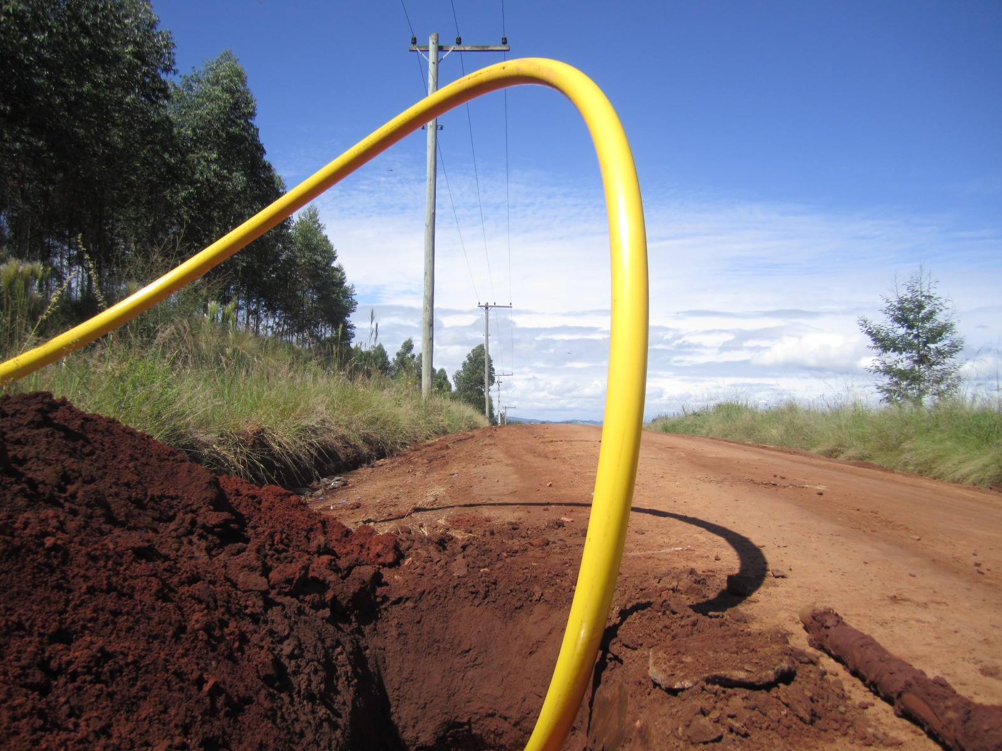
Gas pipes for gas distribution with pressures up to 18 bar can be installed from a roll, using trenchless technology.

The innovation award honors Evonik’s decade-long intensive research along with the company’s efforts to support the requisite approvals for high pressure gas pipes.
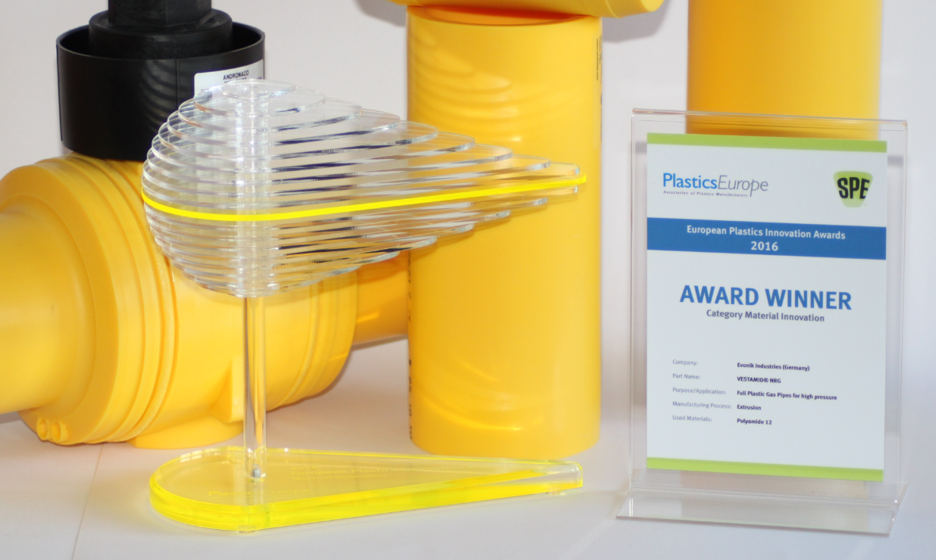

About Resource Efficiency
The Resource Efficiency segment is led by Evonik Resource Efficiency GmbH and supplies high performance materials for environmentally friendly as well as energy-efficient systems to the automotive, paints & coatings, adhesives, construction, and many other industries. This segment employed about 7,800 employees, and generated sales of around €4 billion in 2014.
About Evonik
Evonik, the creative industrial group from Germany, is one of the world leaders in specialty chemicals, operating in the Nutrition & Care, Resource Efficiency and Performance Materials segments. The company benefits from its innovative prowess and integrated technology platforms. In 2014 more than 33,000 employees generated sales of around €12.9 billion and an operating profit (adjusted EBITDA) of about €1.9 billion.

Disclaimer
In so far as forecasts or expectations are expressed in this press release or where our statements concern the future, these forecasts, expectations or statements may involve known or unknown risks and uncertainties. Actual results or developments may vary, depending on changes in the operating environment. Neither Evonik Industries AG nor its group companies assume an obligation to update the forecasts, expectations or statements contained in this release.

