September 16, 2016

**Specialized Press Contact**

**Janusz Berger**

High Performance Polymers

Phone +49 2365 49-9227

Fax +49 2365 49-809878

janusz.berger@evonik.com

**Evonik Resource Efficiency GmbH**

Rellinghauser Strasse 1-11

45128 Essen  
Germany

Phone +49 201 177-01

Fax +49 201 177-3475

[www.evonik.com](http://www.evonik.com)

**Supervisory Board**

Dr. Ralph Sven Kaufmann, Chairman

**Management Board**

Dr. Claus Rettig, Chairman

Dr. Johannes Ohmer,   
Simone Hildmann,   
Alexandra Schwarz

Registered Office: Essen

Register Court: Essen Local Court

Commercial Registry B 25783

VAT ID no. DE 815528487

**Evonik brings the "Kö" into the exhibition halls of K 2016**

Evonik is bringing the trend and style of Dusseldorf's Königsallee into the exhibition halls of the state capital of North Rhine-Westphalia: At this year's plastics trade fair, the specialty chemical company is presenting women's fashions! The fascinating part: The elegant garments are made 100 percent of innovative biopolyamide fibers based on VESTAMID® Terra.

The high-tech textile fibers have a lot to offer: maximum wearing comfort and unexcelled performance. They are extremely light, flexible, and breathable. Processed into high-quality fabrics, they have an odor-reducing effect thanks to their lasting natural bacteriostatic characteristics. In addition, they dry quickly and require no ironing. Because of their uniqueness, the innovative high-performance fibers can be processed in all textile applications, including an Italian designer fabric for evening gowns, functional sporting togs, and durable upholstery materials.

**High performance from the castor bean plant**

The fibers are produced from VESTAMID® Terra, a biopolyamide that is obtained 100 per cent from the seeds of the castor bean plant. In addition to the environmental advantage, it is above all the sustainability approach of VESTAMID® Terra that is so convincing. Since castor bean plants can also withstand long periods of drought, they are cultivated in dry areas which are not suitable for any other form of agriculture. The biopolymer from Evonik’s Resource Efficiency Segment therefore has no adverse effect on the human food chain. Unlike various other biopolymers that are based on natural products grown on cropland.

The product development process profited from Evonik's technical expertise in the area of high-performance plastics as well as the fiber-processing experience of Fulgar, an Italian fiber manufacturer, which markets the biopolyamide fibers under the brand name EVO®.

With VESTAMID® Terra, Evonik offers three variants of biopolyamides, PA 610, PA 1010, and PA 1012, which differ in their profile of properties and close gaps in the previously available range of properties of polyamides. They are long-lasting, durable, and meet the requirements of demanding applications, for example in the automotive, sports, and textile industries. Typical applications of VESTAMID® Terra products are injection molding, fibers, powders, extrusion, and films.

Additional information at www.vestamid-terra.com

*Learn more about the high-performance plastic VESTAMID® Terra at Stand B28, Hall 6 at the plastics trade fair in Dusseldorf from October 19th to 26th.*

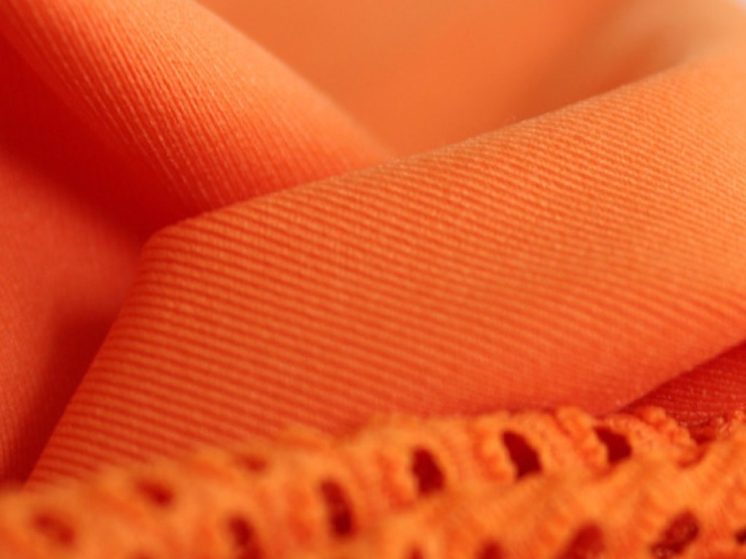

***Photo caption:*** *Fabrics made from the bio polyamide fibers EVO® based on VESTAMID® Terra (Source:Fulgar).*

**About Resource Efficiency**

The Resource Efficiency segment is led by Evonik Resource Efficiency GmbH and supplies high performance materials for environmentally friendly as well as energy-efficient systems to the automotive, paints & coatings, adhesives, construction, and many other industries. This segment employed about 8,600 employees, and generated sales of around €4.3 billion in 2015.

**About Evonik**

Evonik, the creative industrial group from Germany, is one of the world leaders

in specialty chemicals. Profitable growth and a sustained increase in the value of

the company form the heart of Evonik’s corporate strategy. Its activities focus on

the key megatrends health, nutrition, resource efficiency and globalization. Evonik benefits specifically from its innovative prowess and integrated technology

platforms.

Evonik is active in over 100 countries around the world. In fiscal 2015 more than

33,500 employees generated sales of around €13.5 billion and an operating profit (adjusted EBITDA) of about €2.47 billion.

**Disclaimer**

In so far as forecasts or expectations are expressed in this press release or where our statements concern the future, these forecasts, expectations or statements may involve known or unknown risks and uncertainties. Actual results or developments may vary, depending on changes in the operating environment. Neither Evonik Industries AG nor its group companies assume an obligation to update the forecasts, expectations or statements contained in this release.