October 10, 2017

Specialized press contact
Janusz Berger
Communication Manager
High Performance Polymers
Phone +49 2365 49-9227
janusz.berger @evonik.com

Evonik Resource Efficiency GmbH
Rellinghauser Straße 1-11
45128 Essen
Germany
Phone +49 201 177-01
Fax +49 201 177-3475
www.evonik.com

Supervisory Board
Dr. Harald Schwager, Chairman

Executive Board
Dr. Claus Rettig, Chairman
Dr. Johannes Ohmer,
Simone Hildmann,
Alexandra Schwarz

Registered Office: Essen
Register Court: Essen Local Court
Commercial Registry B 25783
VAT ID no. DE 815528487
Performing at the limit: Evonik presents new VESTAMID® molding compound for applications in professional sports

Evonik has developed a new high-performance plastic for demanding applications in professional sports. VESTAMID® CW1401 is an impact-modified polyamide 12 (PA 12) which combines good elasticity and stability at temperatures as low as -40°C.

The new PA 12 molding compound has excellent low-temperature impact strength which, at 101 kJ/m², is twice as strong as other materials. This means that it can be used in applications where extreme pressure is applied and where stable properties are required from the materials at low temperatures.

This combination makes VESTAMID® CW1401 the material of choice for the new ski and snowboard boots of the Austrian professional brand UPZ. “In downhill ski races and especially in snowboard races, the pressure applied to the boot is several times greater than is the case with the average amateur skier or boarder,” says Wolfgang Aigner, managing director of AITEC GmbH. “The material used in the boot must be capable of permanently withstanding extreme loads.”

VESTAMID® CW1401 fulfills all these criteria. The boot parts that are subject to the greatest pressure are manufactured from Evonik’s high-performance plastic using an injection-molding process. They ensure optimal power transfer during the race while allowing the greatest possible flexibility and maximum comfort.

“New innovative products, which have been custom developed in close collaboration with our customers, form an important pillar of our organic growth,” says Dr. Iordanis Savvopoulos, head of the Granules & Compounds Product Line at Evonik.

New meaning of “Added value for sport”
For almost 30 years, Evonik has been supplying innovative Smart Materials concepts to the sporting industry. The High Performance Polymers Business Line has given a new meaning to the claim “Added value for sport.” As a partner in the development and manufacture of high-performance polymers with a global production, distribution, and service network, we have made a significant contribution to the successful implementation of new ideas and product concepts of the leading sports equipment manufacturers. In our research centers in Marl and Darmstadt (Germany), Shanghai (China), and Indiana (USA) we collaborate closely with the sporting goods industry to develop innovative material solutions which enable our customers to meet the market requirements of today and tomorrow.

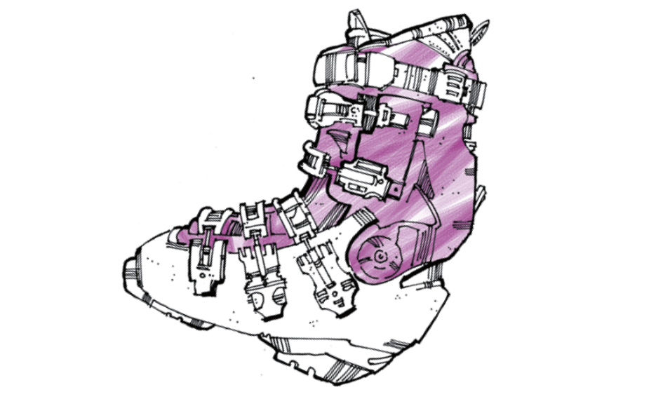

Image caption: The Austrian manufacturer of UPZ-brand ski and snowboard boots relies on the high-performance plastic polyamide 12 from Evonik’s VESTAMID® brand.

Learn more about VESTAMID® polyamide 12 from Evonik at our booth 4117 in Hall A4 at FAKUMA, October 17 – 27, in Friedrichshafen, Germany.

Company information
Evonik is one of the world leaders in specialty chemicals. The focus on more specialty businesses, customer-orientated innovative prowess and a trustful and performance-oriented corporate culture form the heart of Evonik’s corporate strategy. They are the lever for profitable growth and a sustained increase in the value of the company. Evonik benefits specifically from its customer proximity and leading market positions. Evonik is active in over 100 countries around the world with more than 35,000 employees. In fiscal 2016, the enterprise generated sales of around €12.7 billion and an operating profit (adjusted EBITDA) of about €2.165 billion.

About Resource Efficiency
The Resource Efficiency segment is led by Evonik Resource Efficiency GmbH and supplies high performance materials for environmentally friendly as well as energy-efficient systems to the automotive, paints & coatings, adhesives, construction, and many other industries. This segment employed about 9,000 employees, and generated sales of around €4.5 billion in 2016.

Disclaimer
In so far as forecasts or expectations are expressed in this press release or where our statements concern the future, these forecasts, expectations or statements may involve known or unknown risks and uncertainties. Actual results or developments may vary, depending on changes in the operating environment. Neither Evonik Industries AG nor its group companies assume an obligation to update the forecasts, expectations or statements contained in this release.

