July 2, 2018

Specialized Press Contact
Dr. Ursula Keil
Market Communications
High Performance Polymers
Phone +49 2365 49-9878
ursula.keil@evonik.com

Evonik Resource Efficiency GmbH
Rellinghauser Straße 1-11
45128 Essen
Phone +49 201 177-01
Fax +49 201 177-3475
www.evonik.com

Supervisory Board
Dr. Harald Schwager, Chairman
Managing Directors
Dr. Claus Rettig, Chairman
Dr. Johannes Ohmer
Simone Hildmann
Alexandra Schwarz

Registered Office: Essen
Register Court: Essen Local Court
Commercial Registry B 25783
VAT ID no. DE 815528487

A strong bond—plastic-rubber components without adhesives

LWB Steinl GmbH & Co.KG, Altdorf, and Evonik Industries, Essen, are combining their experience to manufacture a rotation-symmetrical plastic/rubber composite part: Evonik supplies polyamide 612 VESTAMID® DX9325 for adhesive-free bonding with EPDM, and LWB Steinl supplies its expertise in two-component injection molding. This automated manufacturing process can be viewed during the German Rubber Conference (DKT 2018) from July 2 to 5 at LWB Steinl’s stand 309 in hall 12.

Wherever rubber parts must be permanently fixed or mounted, composite parts made of a hard component and an elastomer have proven their worth. For the purposes of weight reduction, the hard component that has traditionally been made of metal has been replaced in recent times by suitable plastics. These offer two further advantages: They do not corrode, and in an injection molding process, they can be efficiently formed into complex molded parts. This gives the designer significantly greater flexibility when designing complex components. The bonding between hard and soft component—the decisive criterion for the long-term functioning of composite parts, especially those subject to dynamic stress—is usually achieved using adhesive agents, which are applied in additional processing steps. Protective measures are required against emissions from the solution used and the solution must also be disposed of in an environmentally friendly manner.

Evonik has developed various plastic-compounds, which have rendered adhesive agents superfluous. Components made of these compounds form tight and permanent bonds with suitable rubber compounds without the need for pretreatment or the application of adhesives or bonding agents. VESTAMID® DX9325 is an approx. 40% glass-fiber-reinforced polyamide 612 compound, which has been developed specifically for plastic-rubber-compound technology. It can also be covulcanized with EPDM rubber. As a semi-crystalline material, VESTAMID® DX9325 has excellent chemical resistance, for example, to fuels, oils and fats.

The composite part with EPDM can be manufactured in a single-step, mostly automated procedure, similar to two-component injection molding in a single tool. There is no need for multiple handling of the components, most sources of error are avoided, and the reject rate falls. Depending on the plant-specific conditions, therefore, cost savings of up to 30% can be achieved.

You can find out more about the patented plastic-rubber-bonding process, additional PA612, PPA and PPE molding compounds that have been developed specifically for the process, and their adhesive-free bonding to SBR, NR/SBR, NBR/SBR, NBR, XNBR, HNBR, AEM and FPM at Evonik’s stand 107 in hall 12.

Image caption:
The rotation-symmetrical plastic/rubber composite part made of polyamide 612 VESTAMID® DX9325 and EPDM is manufactured without adhesive agents in an automated procedure.
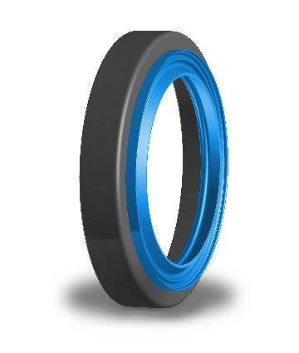

About Evonik
Evonik is one of the world leaders in specialty chemicals. The focus on more specialty businesses, customer-orientated innovative prowess and a trustful and performance-oriented corporate culture form the heart of Evonik’s corporate strategy. They are the lever for profitable growth and a sustained increase in the value of the company. Evonik benefits specifically from its customer proximity and leading market positions. Evonik is active in over 100 countries around the world with more than 36,000 employees. In fiscal 2017, the enterprise generated sales of €14.4 billion and an operating profit (adjusted EBITDA) of €2.36 billion.

About Resource Efficiency
The Resource Efficiency segment is led by Evonik Resource Efficiency GmbH and produces high performance materials and specialty additives for environmentally friendly as well as energy-efficient systems to the automotive, paints & coatings, adhesives, construction, and many other industries. This segment employed about 10,000 employees, and generated sales of around €5.4 billion in 2017.

Disclaimer
In so far as forecasts or expectations are expressed in this press release or where our statements concern the future, these forecasts, expectations or statements may involve known or unknown risks and uncertainties. Actual results or developments may vary, depending on changes in the operating environment. Neither Evonik Industries AG nor its group companies assume an obligation to update the forecasts, expectations or statements contained in this release.

