February 4, 2019

Specialized Press Contact
Dr. Ursula Keil
High Performance Polymers
Phone +49 2365 49-9878
ursula.keil@evonik.com

Evonik Resource Efficiency GmbH
Rellinghauser Straße 1-11
45128 Essen
Phone +49 201 177-01
Fax +49 201 177-3475
www.evonik.com

Supervisory Board
Dr. Harald Schwager, Chairman
Managing Directors
Dr. Claus Rettig, Chairman
Dr. Johannes Ohmer
Simone Hildmann
Alexandra Schwarz

Registered Office: Essen
Register Court: Essen Local Court
Commercial Registry B 25783
VAT ID no. DE 815528487
Evonik’s new polyamide 12 complex fully on schedule
Essen, Germany. Evonik has completed the conceptual and basic engineering phase for building its new polyamide 12 (PA12) production complex on schedule by the end of the past year and has now entered the project implementation phase. The facility complex is scheduled to become operational in the first six months of 2021.
The some €400 million project, Evonik’s largest investment in Germany so far, is expected to increase the Group’s overall capacity for PA12 by more than 50 percent. Additional facilities for producing the polymer and its precursors will be constructed at the Marl Chemical Park in North Rhine-Westphalia and will supplement the existing PA12 production plant.
“This project is a special challenge,” explains Dr. Ralf Düssel, the Head of the High Performance Polymers Business Line at Evonik, which, among other products, manufactures VESTAMID® and VESTOSINT®, the Group’s PA12 granules and powders. “In Evonik's engineering unit, some 80 engineers are working on the project. We have also contracted a well-known, globally active technical service provider for the detail engineering of individual sub-projects. The construction project is located in the direct vicinity of ongoing production, with special safety standards, and we have to keep areas for construction containers, material storage, and pre-assembly open in addition to the actual construction sites. The Marl Chemical Park offers us optimal conditions for this extraordinary feat. Once we start up the new facility, the existing structures that have been in place for over 50 years will be used for product distribution.”
Polyamide 12 is in demand in attractive growth markets such as the automotive industry, oil and gas pipelines, and 3D printing. “This investment supports Evonik's consistent concentration on specialty chemicals. As a high-performance polymer for special applications, polyamide 12 is an important aspect of the Smart Materials Growth Engine,” adds Dr. Claus Rettig, the Head of the Resource Efficiency Segment. “What's more, products made from PA12 are usually energy-efficient: They are durable and require less maintenance than steel components, for example in gas pipelines, and contribute to lightweight construction, e.g. in automotive design.”
Figure caption:
Additional facilities for producing polyamide 12 and its precursors will be constructed at the Marl Chemical Park in North Rhine-Westphalia and will supplement the existing production plants.
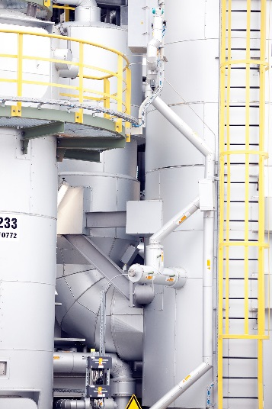

About Evonik
Evonik is one of the world leaders in specialty chemicals. The focus on more specialty businesses, customer-orientated innovative prowess and a trustful and performance-oriented corporate culture form the heart of Evonik’s corporate strategy. They are the lever for profitable growth and a sustained increase in the value of the company. Evonik benefits specifically from its customer proximity and leading market positions. Evonik is active in over 100 countries around the world with more than 36,000 employees. In fiscal 2017, the enterprise generated sales of €14.4 billion and an operating profit (adjusted EBITDA) of €2.36 billion.

About Resource Efficiency
The Resource Efficiency segment is led by Evonik Resource Efficiency GmbH and produces high performance materials and specialty additives for environmentally friendly as well as energy-efficient systems to the automotive, paints & coatings, adhesives, construction, and many other industries. This segment employed about 10,000 employees, and generated sales of around €5.4 billion in 2017.

Disclaimer
In so far as forecasts or expectations are expressed in this press release or where our statements concern the future, these forecasts, expectations or statements may involve known or unknown risks and uncertainties. Actual results or developments may vary, depending on changes in the operating environment. Neither Evonik Industries AG nor its group companies assume an obligation to update the forecasts, expectations or statements contained in this release.

