Polymer Optical Fibers with VESTAMID®: The Clever Solution for Communication Infrastructure in Automotive Applications
October 24, 2007

Dr. Ursula Keil
Marketing Support
Phone +49 2365 49-9878
Fax +49 2365 49-5992
ursula.keil@evonik.com

High transmission capacity by polymer optical fibers

Two concerted PA 12 compounds form the protective jacketing

Marl - The High Performance Polymers Business Unit of Essen, Germany-based Evonik Industries offers various VESTAMID® molding compounds for a dual-layer jacket system for polymer optical fibers (POF). The data carrier of the data bus system, a PMMA fiber, is mechanically protected by inner and outer layers of polyamide 12.

Polymer optical fibers most suitable
Hi-tech communication technology in automotive and mechanical engineering applications depends on light transmission. For industrial use, an optical fiber must have high transmission capacity and be economical, reliable, and, if necessary, fire resistant. In particular, optical fiber systems with polymer optical fiber (POF), whose elements can be up to ten meters long, offer the automotive industry the best ratio of data transmission to system price and are easily laid, even in applications requiring small bend radii. As their use over the last few years has shown, they are very robustly built for installation and continuous use. The optical fiber is fixed in such a way that it has a long service life and resists high pull-out forces, even under dynamic stress.

Dual-layer protective jacket of polyamide 12
With these requirements in view, the High Performance Polymers Business Unit has developed a VESTAMID® dual-layer jacket system to protect the optical data carrier, a PMMA fiber. The first, black layer consists of a modified polyamide 12 and, as required, adheres firmly to the PMMA core. In addition to providing mechanical protection, it increases the refractive index by virtue of its color, so that light scattering is avoided and optical transmission improved. It is also suitable for laser welding, so that the optical plug-in connectors can be welded on.

By contrast, the second layer should adhere only slightly to the first so that the system can be easily fabricated. It must make the system resistant to aging and battery acids. A specially plasticized, halogen-free, flame-retardant VESTAMID® molding compound with good chemical resistance and hydrolytic stability satisfies these requirements.

Image: Structure of Polymer Optical Fibers with VESTAMID®

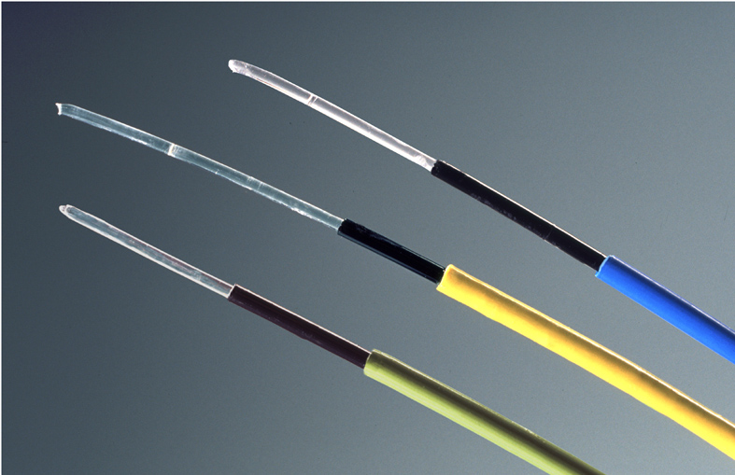

Company information
Evonik Industries AG is the creative industrial group which operates in three highly profitable, promising business areas: Chemicals, Energy and Real Estate. Evonik is a global leader in specialty chemicals, an expert in power generation from hard coal and renewable energies, and one of the largest private residential real estate companies in Germany. Our strengths are creativity, specialization, continuous self-renewal, and reliability.

Evonik Industries is active in over 100 countries around the world. In fiscal 2006 around 43,000 employees generated sales of €14.8 billion and operating Profit (EBIT) of over €1.2 billion. Evonik plans to enter the capital market in the first half of 2008.

Disclaimer
In so far as forecasts or expectations are expressed in this press release and where our forward-looking statements concern the future, these forecasts, expectations and statements may involve known or unknown risks and uncertainties. Actual results or developments may vary, depending on changes in the operating environment. Evonik Industries AG assumes no obligation to update the forecasts, expectations or statements contained in this release.

