Nitrogen oxide reduction: Lines made from VESTAMID® compounds satisfy requirements
February 18, 2011

Dr. Ursula Keil
Marketing Support High Performance Polymers
Phone +49 2365 49-9878
Fax +49 2365 49-809878
ursula.keil @evonik.com

Essen, Germany-based Evonik Industries offers a variety of VESTAMID® polyamide 12 compounds that help automobile manufacturers develop systems for reducing nitrogen oxide in diesel vehicles. All the grades offered by Evonik have performed excellently in tests, and some are already in use.

The process
A 32.5-percent aqueous solution of urea serves as the reducing agent in systems developed today by car makers for the selective catalytic reduction (SCR) of nitrogen oxides from diesel engines. The VDA (German Association of the Automotive Industry) has registered this solution under the brand AdBlue®. At temperatures above 60°C, water decomposes AdBlue®, yielding carbon dioxide and ammonia; the latter in turn reacts with nitrogen oxides, forming water and nitrogen and thus reducing the emission of nitrogen oxides by about 90 percent.

AdBlue® places heavy demands on lines in SCR systems. They must be resistant to urea and ammonia as well as any gas mixture flowing back from the catalyst. Because the urea solution is heated to up to 60°C, but freezes with expansion at -11°C, good hydrolytic resistance and bursting strength at higher temperatures are essential, along with high impact resistance and elasticity at low temperatures.

VESTAMID® for SCR systems
Various VESTAMID® polyamide 12 compounds satisfy all these requirements. Evonik helps car makers develop their individual systems by offering them a variety of products. All VESTAMID® compounds have been subjected to a recirculation test with AdBlue® at 60°C and 80°C (with external air temperatures of 40°C and 50°C respectively) over a period of 5,000 hours, to check for any changes in their mechanical properties. All of the grades tested have excellent values for strain at break, bursting strength, and, in particular, low-temperature impact strength at -40°C. Of all the grades tested, VESTAMID® LX9008 best satisfied all the requirements; VESTAMID® L2140 and X7293 are already being used in SCR systems.
Evonik has been producing polyamide 12 and 612 as well as polyamide 12 elastomer (PEBA) compounds, for about 40 years, and, more recently, polyphthalamide and polyamides based on renewable raw materials—all under the brand name VESTAMID®. Leading automotive manufacturers have been using the materials for decades. To further strengthen its leading global market position in polyamide 12 and, as a reliable partner, to continue offering its customers supply security in the future, Evonik keeps expanding its capacity for the polymers as well as their precursors.

Visit us at the VDI Plastics in Automotive Engineering conference in Mannheim on April 6 and 7, 2011, at booths 55-57.

Figure caption:
Illustration of catalytic reduction of nitrogen oxides.

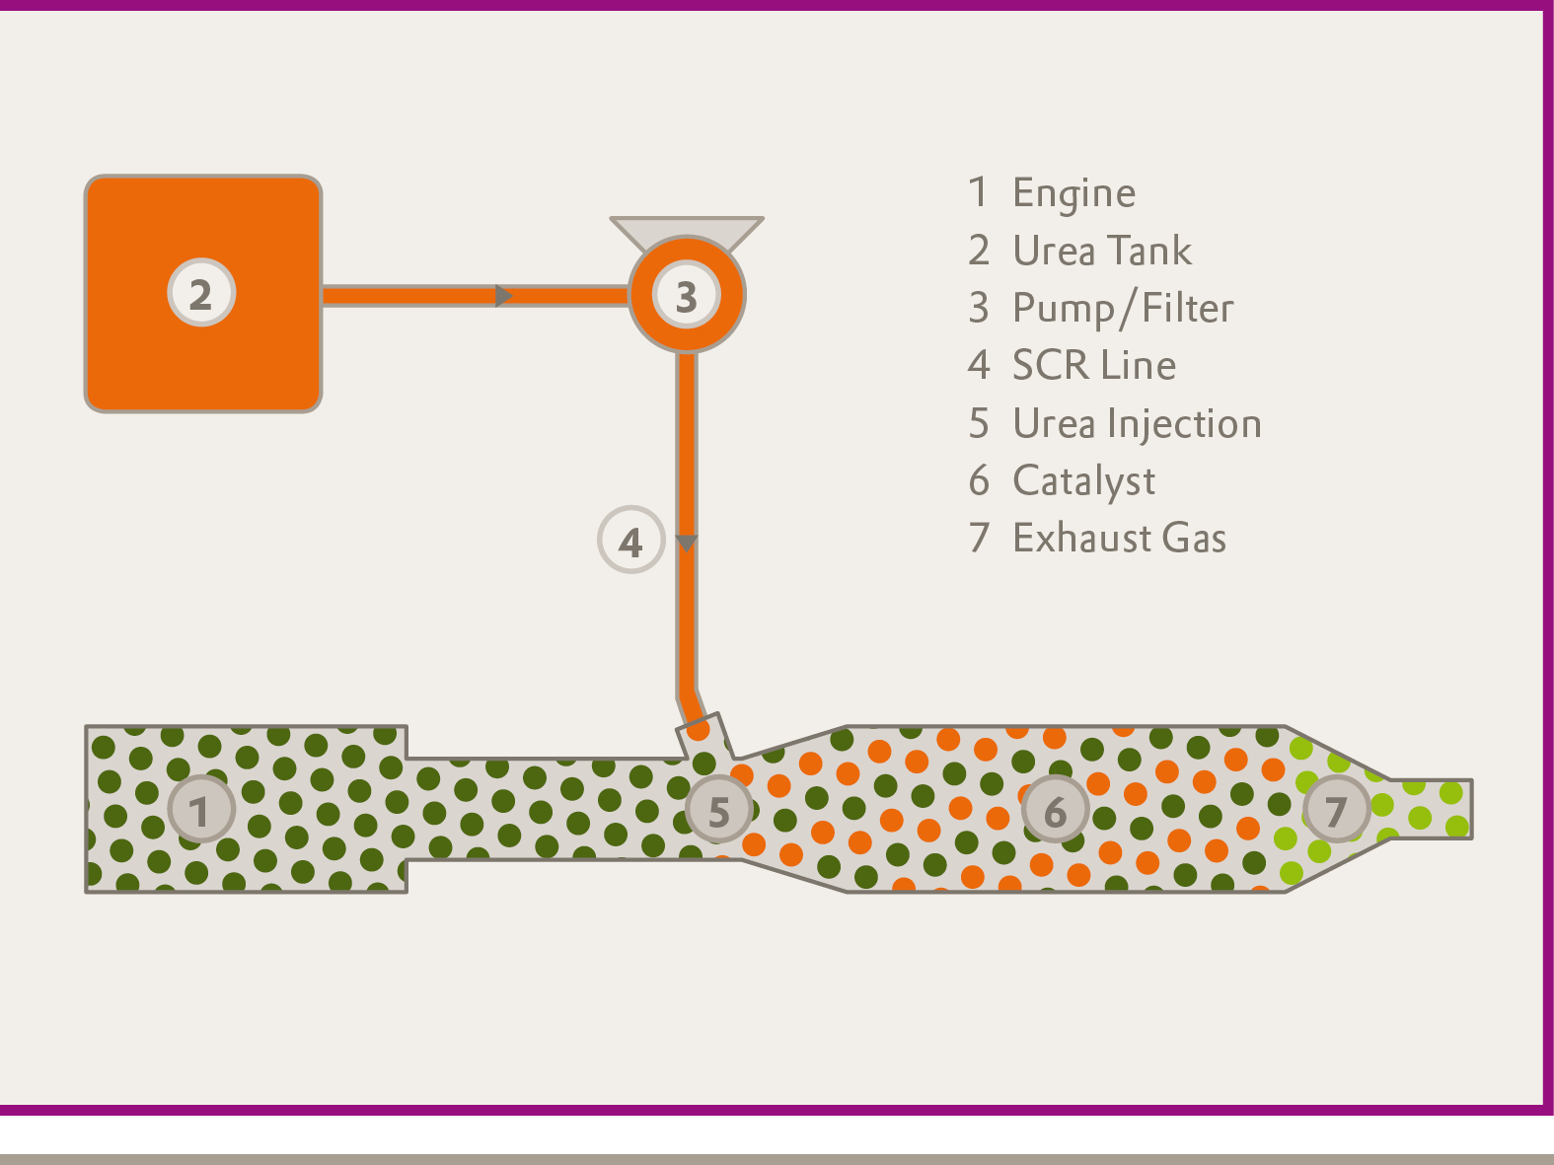

About Evonik
Evonik Industries is the creative industrial group from Germany. In our core business of specialty chemicals, we are a global leader. In addition, Evonik is an expert in power generation from hard coal and renewable energies, and one of the largest private residential real estate companies in Germany. Our company’s performance is shaped by creativity, specialization, continuous self-renewal, and reliability.
Evonik is active in over 100 countries around the world. In its fiscal year 2009 about 39,000 employees generated sales of about €13.1 billion and an operating profit (EBITDA) of about €2.0 billion.

Disclaimer
In so far as forecasts or expectations are expressed in this press release or where our statements concern the future, these forecasts, expectations or statements may involve known or unknown risks and uncertainties. Actual results or developments may vary, depending on changes in the operating environment. Neither Evonik Industries AG nor its group companies assume an obligation to update the forecasts, expectations or statements contained in this release.

