Solutions for ecologically sustainable automobile manufacture
March 15, 2011

Thomas Lange
Marketing Support
High Performance Polymers
Phone +49 2365-49-9227
Fax +49 2365-49-809227
thomas.lange2@evonik.com

Doris Hirsch
PR-Management
Acrylic Polymers
Phon +49 6151 18-4079
Fax +49 6151 18-3177
doris.hirsch@evonik.com

In developing new materials, Essen, Germany-based Evonik Industries has for many years paid attention to ecologically sustainable solutions. These include, on the one hand, plastics for lightweight construction, as are used in hybrid plastic-metal components and plastic glazing and, on the other, molding compounds that reduce emissions, either during their own production or by their function in components. Examples are bio-based plastics, infrared radiation-reflecting molding compounds, and polyamide molding compounds used in the lines of nitrogen-oxide reduction systems in diesel vehicles.

Even lighter hybrid components
Evonik has developed an adhesion promoter system that improves the performance of hybrid components and reduces material usage by up to 25 percent. This leads to significant cost advantages as well as reduced CO₂ emissions. The copolyamide adhesion promoter VESTAMELT® bonds excellently to metallic as well as polymer surfaces. All the known disadvantages of existing hybrid components such as warpage, differential shrinkage, and defective bonding of metal and plastic are avoided.

High-performance and bio-based—no contradiction in terms
In VESTAMID® Terra, Evonik offers high-performance polymers for automotive construction that are up to 100 percent bio-based. Like purely petroleum-based polyamides, these have excellent mechanical and physical properties. But VESTAMID® Terra products have an added plus. Thanks to their more favorable CO₂ balance, they make important contributions toward conservation of fossil raw materials and reduction of the greenhouse effect, as has been verified by the German safety monitoring agency TÜV.

Reduction of nitrogen oxides
With its range of VESTAMID® polyamide 12 molding compounds, Evonik supports car makers in developing their individual systems for catalytic reduction of nitrogen oxides. These molding compounds combine good hydrolytic resistance and bursting strength at relatively high temperatures with high impact resistance and elasticity in the cold.

Transparency and lightness: PLEXIGLAS® automotive glazing
Lightweight vehicles save fuel and are therefore kinder to the environment. While this is important for cars with conventional transmissions, weight is even more crucial for vehicles with electric engines. PLEXIGLAS® glazing, being 40 to 50 percent lighter than glass, can make a major contribution to lightweight construction.

To cover the complete range of glazing for automotive construction, Evonik is pursuing two lines of development: monolithic and multilayer systems based on PLEXIGLAS®. A 5mm thick coated sheet has already received ECE R 43 certification for side and rear windows and roof glazing. PLEXIGLAS® glazing has been tested under practical conditions in a Lotus race car. This has recently been fitted also with a front windshield made from the high-transparency, weather-resistant, lightweight material and has passed its first test with flying colors.

Holding off the heat
Roofs produced with PLEXIGLAS® Heatstop (formerly CoolTouch®) are 17 percent lighter than steel. But this is not their only contribution toward CO₂ reduction: As a result of its sophisticated formulation, the specialty molding compound reflects a good proportion of the sun's infrared radiation. As a result, black components do not heat up as intensely as those made of other comparable materials, and the reduction may be as high 22 percent. This has been confirmed in practical tests by the Staatliche Materialprüfungsanstalt (an autonomous materials testing institute). The tests were performed on a roof structure using material from current production and installed in an Opel Corsa in Spain. The results achieved with this test vehicle are impressive: The inside temperature in the car can be reduced by up to 5°C, and the optimum comfort temperature of 22°C can be attained with air conditioning up to 25 percent faster, reducing the energy required for air conditioning.

Visit us at Booths 55 –57 at the VDI conference on plastics in automotive construction in Mannheim on April 6 and 7.

Figure captions:
PLEXIGLAS® glazing is lightweight and highly transparent.

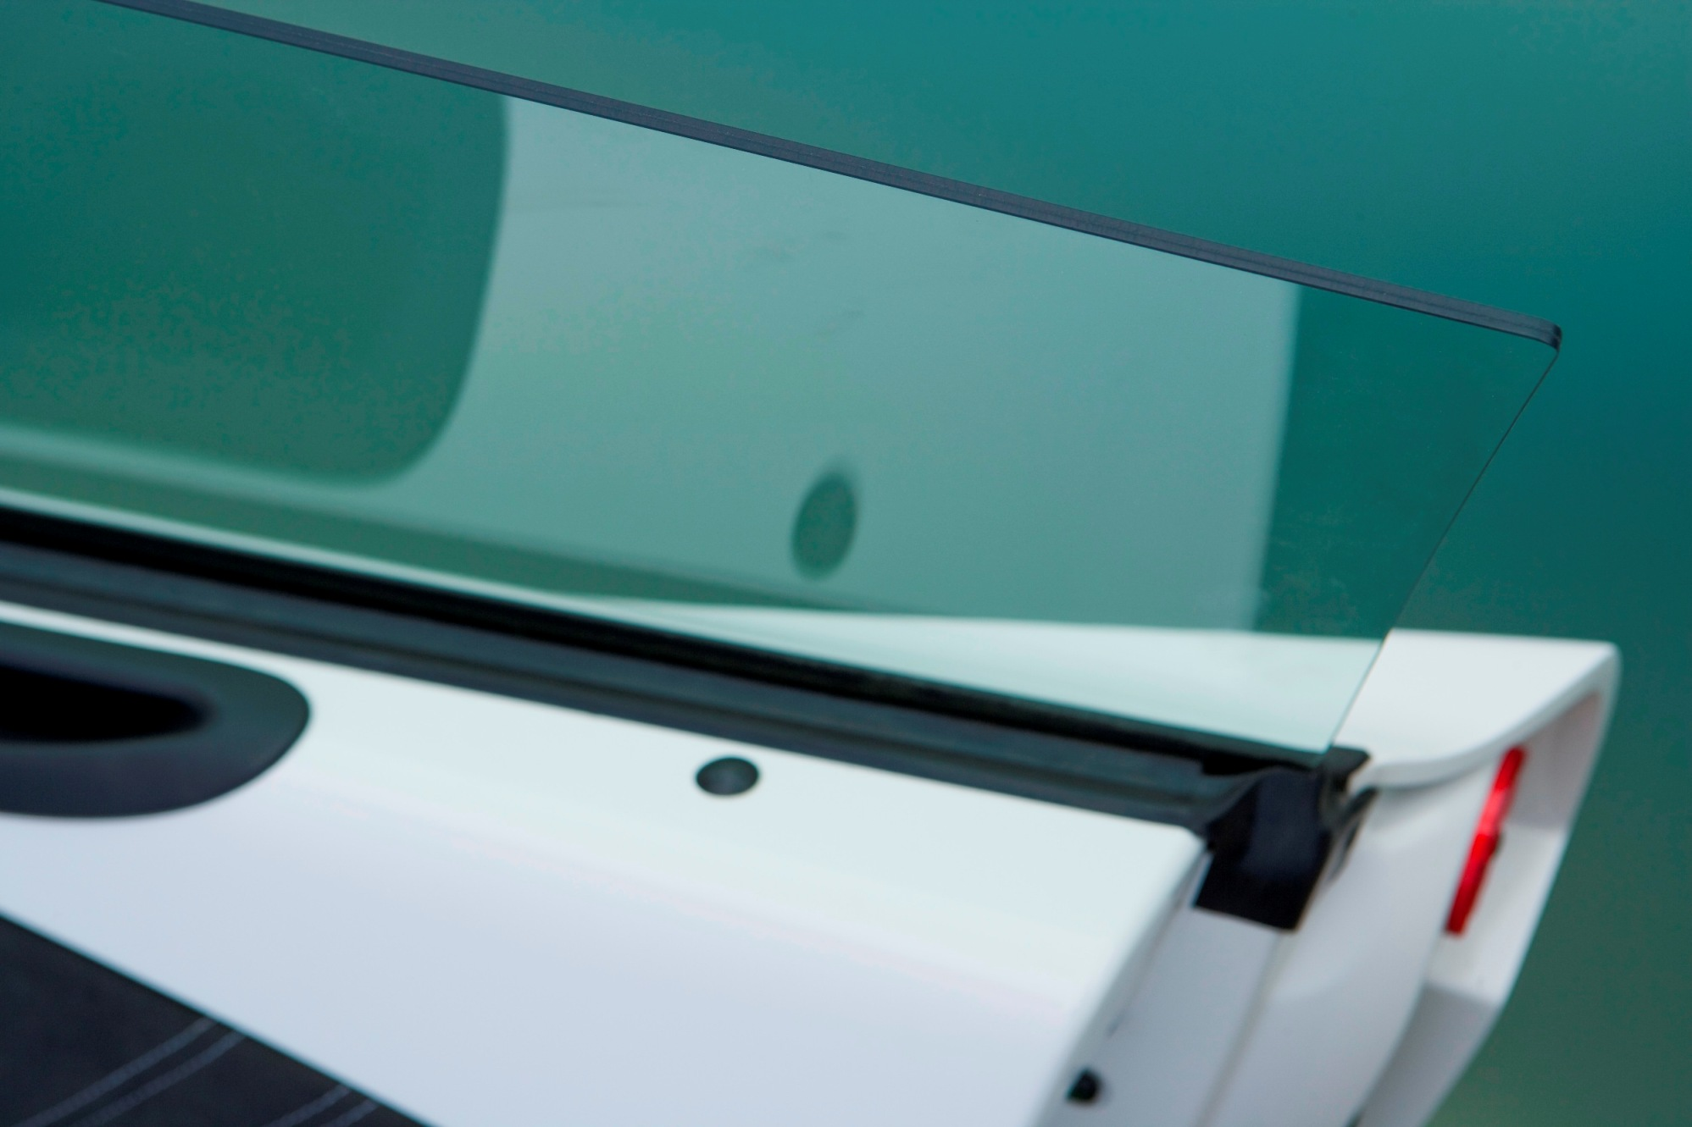

Illustration of catalytic reduction of nitrogen oxides.

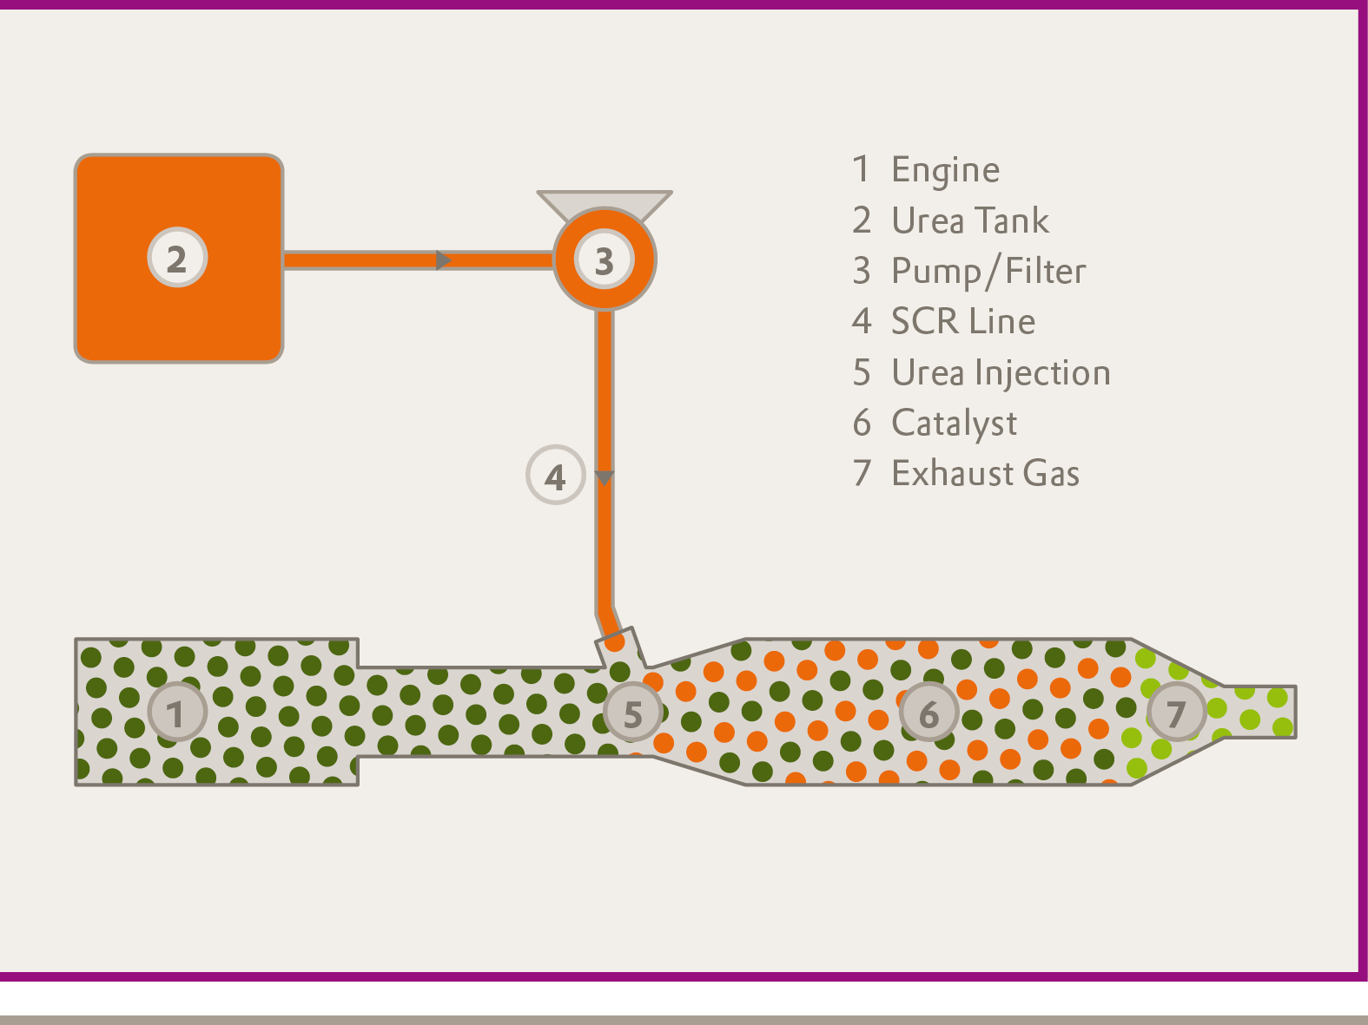

The Performance Polymers Business Unit of Evonik Industries is a worldwide manufacturer of PMMA products sold under the PLEXIGLAS® trademark on the European, Asian, African and Australian continents and under the trademark ACRYLITE® in the Americas.

About Evonik
Evonik Industries is the creative industrial group from Germany. In our core business of specialty chemicals, we are a global leader. In addition, Evonik is an expert in power generation from hard coal and renewable energies, and one of the largest private residential real estate companies in Germany. Our company’s performance is shaped by creativity, specialization, continuous self-renewal, and reliability.
Evonik is active in over 100 countries around the world. In its fiscal year 2009 about 39,000 employees generated sales of about €13.1 billion and an operating profit (EBITDA) of about €2.0 billion.

Disclaimer
In so far as forecasts or expectations are expressed in this press release or where our statements concern the future, these forecasts, expectations or statements may involve known or unknown risks and uncertainties. Actual results or developments may vary, depending on changes in the operating environment. Neither Evonik Industries AG nor its group companies assume an obligation to update the forecasts, expectations or statements contained in this release.

