For when things hot up in the engine compartment: New VESTAMID® high-temperature polyamide doubles the lifetime of the lines
October 14, 2014

Dr. Ursula Keil
Contact specialized press
High Performance Polymers
Phone +49 2365-49-9878
Fax +49 2365-49-809878
ursula.keil@evonik.com

Evonik Industries AG
Rellinghauser Straße 1-11
45128 Essen
Germany
Phone +49 201 177-01
Fax +49 201 177-3475
www.evonik.com
www.rohacell.com

Chairman of the Supervisory Board
Dr. Werner Müller
Executive Board
Dr. Klaus Engel, Chairman
Christian Kullmann
Thomas Wessel
Patrik Wohlhauser
Dr. Uwe Wolf

Registered Office: Essen
Register Court: Essen Local Court
Commercial Registry B 19474
VAT ID no. DE 811160003

Thermal loads in the engine compartments of cars have risen greatly over the last few years. To withstand such loads, Evonik Industries, Marl, has been continually developing its VESTAMID® polyamide extrusion compounds for tubing systems. It is now complementing its product portfolio with a new high-temperature polyamide, distinguished by particularly high resistance to continuously high working temperatures.

Among the most important requirements placed on the automotive industry is lightweight construction: Every kilogram saved means less fuel consumption and fewer emissions. Plastics are therefore favored materials for lightweight construction, but they must be adapted to meet the increased temperature requirements in the engine compartment. In VESTAMID® EX9350 Evonik has already presented an extrusion compound for brake booster lines that satisfies these requirements even under racing conditions, as was demonstrated in 2013. Tubing made from the new VESTAMID® extrusion compound, which can be processed on standard extrusion lines, show twice the durability of VESTAMID® EX9350 in tests at 150°C.

Tubing systems made from the VESTAMID® development extrusion compound are lighter than rubber hose assemblies and more space-saving installation can be realized so that a lower volume is required; they are also simply and safely connected by quick connectors.

We would be happy to provide more detailed information to visitors to our stand (4117, in hall A4) at FAKUMA in Friedrichshafen between October 14 and 18.

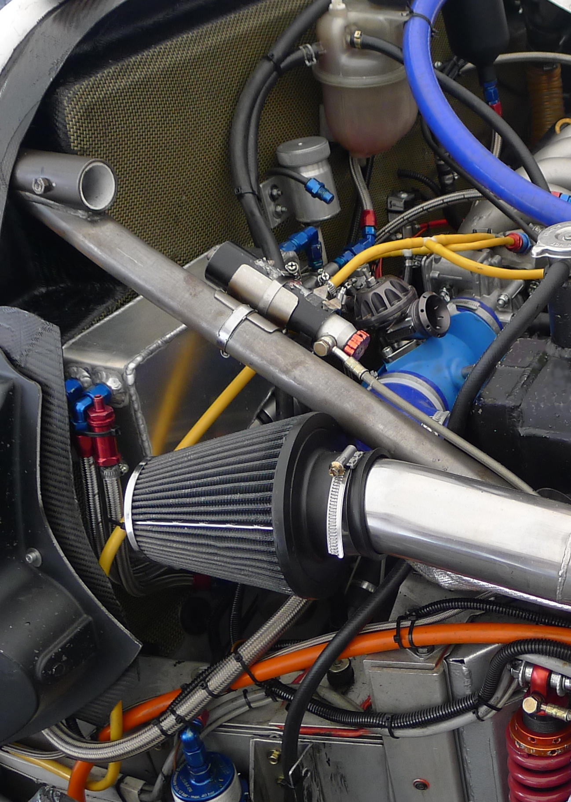

Photo caption:
Tubing made from the new high-temperature resistant VESTAMID® compound can replace rubber hoses in encapsulated engine compartments, saving space and weight.

About Evonik
Evonik, the creative industrial group from Germany, is one of the world leaders in specialty chemicals. Profitable growth and a sustained increase in the value of the company form the heart of Evonik’s corporate strategy. Its activities focus on the key megatrends health, nutrition, resource efficiency and globalization. Evonik benefits specifically from its innovative prowess and integrated technology platforms.

Evonik is active in over 100 countries around the world. In fiscal 2013 more than 33,500 employees generated sales of around €12.7 billion and an operating profit (adjusted EBITDA) of about €2.0 billion.

Disclaimer
In so far as forecasts or expectations are expressed in this press release or where our statements concern the future, these forecasts, expectations or statements may involve known or unknown risks and uncertainties. Actual results or developments may vary, depending on changes in the operating environment. Neither Evonik Industries AG nor its group companies assume an obligation to update the forecasts, expectations or statements contained in this release.

