August 25, 2016

Specialized Press Contact
Dr. Ursula Keil
High Performance Polymers
Phone 49 2365-49-9878
Fax +49 2365-49-809878
ursula.keil@evonik.com

Evonik Resource Efficiency GmbH
Rellinghauser Strasse 1-11
45128 Essen
Germany
Phone +49 201 177-01
Fax +49 201 177-3475
www.evonik.com
www.vestamid.com

Supervisory Board
Dr. Ralph Sven Kaufmann, Chairman
Management Board
Dr. Claus Rettig, Chairman
Dr. Johannes Ohmer,
Simone Hildmann,
Alexandra Schwarz

Registered Office: Essen
Register Court: Essen Local Court
Commercial Registry B 25783
VAT ID no. DE 815528487
Low extractable fuel line

The multilayer tubing 4800 supplements the proven 4000 series through a system with a low extractable inner layer.
With the multilayer tubing system (MLT) 4800, the world's leading provider of polyamide 12 for multilayer plastic tubing systems, Evonik Industries, Essen, responds to new requirements in the automotive industry – low extractable fuel line systems. The new MLT 4800 system with an inner layer of low extractable VESTAMID® polyamide 612 offers significantly reduced levels of extractable substances.
Alcohol containing fuels and lower fuel consumption
The use of fuels that contain alcohol, for example biofuels containing ethanol, can lead to the extraction of substances from the inner walls of conventional gasoline lines. Under certain extreme conditions these substances can clog the nozzles in new, sensitive fuel systems, which use small-diameter nozzles to create an atomized spray of gasoline and air for fuel injection in order to decrease fuel consumption. To reliably counteract this, the automotive industry is looking for new fuel line materials with significantly reduced extraction.
Existing series expanded
For many years, Evonik has been offering its MLT 7440, a conductive system that fully meets the requirements. The new MLT 4800 now supplements it with a non-conductive system. It is based on the MLT 4300, with an outer layer of VESTAMID® polyamide 12 and a barrier layer of ethylene vinyl alcohol (EVOH) to prevent fuel permeation. In the MLT 4800, however, the PA6 inner layer of the proven system 4300 is replaced by a newly developed, low extractable VESTAMID® polyamide 612, which meets the requirements of automobile manufacturers. The mechanical characteristics, chemical resistance, and permeation behavior are on the same level as the MLT 4300, which is the currently most used MLT in Europe.
VESTAMID® has been in use by prestigious automobile manufacturers for more than 50 years. In addition to molding compounds for monowall applications, Evonik has also developed various multilayer tubing systems with different barrier layers. VESTAMID® polyamide 12 and polyamide 612 are the world's most widely used polyamides for tubing systems in automobiles.
Additional information at www.vestamid.com
Visit us during the K‘2016 in Dusseldorf in Hall 6, Stand B28, and learn more about the low extractable fuel line.

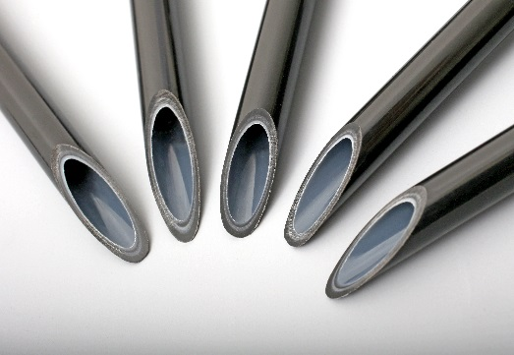
The new multilayer tubing system 4800 with an inner layer of low extractable VESTAMID® polyamide 612 offers significantly reduced levels of extractable substances.

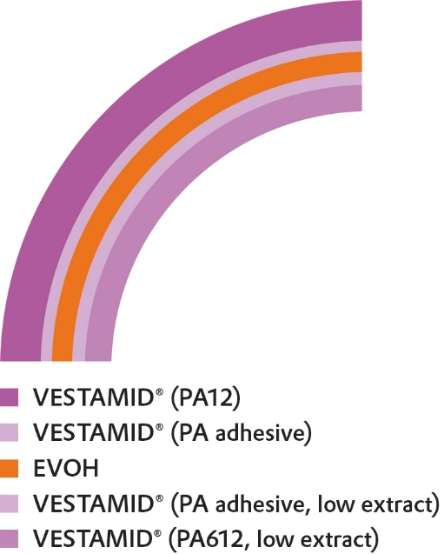
Layer design of the MLT 4800

About Evonik Resource Efficiency
The Resource Efficiency segment is led by Evonik Resource Efficiency GmbH and supplies high performance materials for environmentally friendly as well as energy-efficient systems to the automotive, paints & coatings, adhesives, construction, and many other industries. This segment employed about 8,600 employees, and generated sales of around €4.3 billion in 2015.

About Evonik
Evonik, the creative industrial group from Germany, is one of the world leaders in specialty chemicals. Profitable growth and a sustained increase in the value of the company form the heart of Evonik’s corporate strategy. Its activities focus on the key megatrends health, nutrition, resource efficiency and globalization. Evonik benefits specifically from its innovative prowess and integrated technology platforms.

Evonik is active in over 100 countries around the world. In fiscal 2015 more than 33,500 employees generated sales of around €13.5 billion and an operating profit (adjusted EBITDA) of about €2.47 billion.

Disclaimer
In so far as forecasts or expectations are expressed in this press release or where our statements concern the future, these forecasts, expectations or statements may involve known or unknown risks and uncertainties. Actual results or developments may vary, depending on changes in the operating environment. Neither Evonik Industries AG nor its group companies assume an obligation to update the forecasts, expectations or statements contained in this release.

