Sitting comfortably—on four square centimeters
October 27, 2010

Dr. Ursula Keil
Marketing Support High Performance Polymers
Phone +49 2365 49-9878
Fax +49 2365 49-809878
ursula.keil @evonik.com

VESTAMELT® adhesion promoter makes hybrid components even lighter and more rigid

Plastic and metal hybrid components using VESTAMELT®, a product made by Essen, Germany-based Evonik Industries, behave like a single-material component. The integral joint is so strong that a metal-plastic suspension point with a bond area of just four square centimeters can bear the weight of a heavy armchair—and with the person sitting in it, too. Even a small car weighing a metric ton could be suspended in this way.

This bond owes its extraordinary strength to VESTAMELT®, a structural copolyamide-based adhesion promoter. Wall thicknesses being equal, special chemical modifications ensure that the hybrid components will be able to bear a heavier load than their non-hybrid counterparts. Conversely, hybrid components of equal performance are lighter because less material is needed. A reduction of up to 20% of the material required results in significant cost advantages, as well as lower CO₂ emissions in the automotive sector.

Possible applications include lightweight components for automobile manufacture, facade elements for the construction industry, and housings for cell phones. In addition to plastic-to-metal bonding, steel and polyphthalamide hybrid components and metal-to-metal bonding are possible with VESTAMELT®, too.

Components using the innovative VESTAMELT® primer system have a high degree of chemical resistance, are capable of withstanding heat and mechanical stress, can take cathodic dip coating, and can be welded together. It avoids the typical disadvantages of existing hybrid components like warpage and different shrinkages.

Three ways are used to process the material:
As a granular material, it can be applied directly after the melting process. This means that no film has to be made beforehand, which would require additional energy input. As a powder, it can be applied using an electrostatic coating process, or it can be used as an adhesive in the coil coating process.

Figure caption: The integral joint of plastic and metal hybrid components using VESTAMELT® is so strong that a suspension point with a bond area of just four square centimeters could bear the weight of even a small car weighing a metric ton.

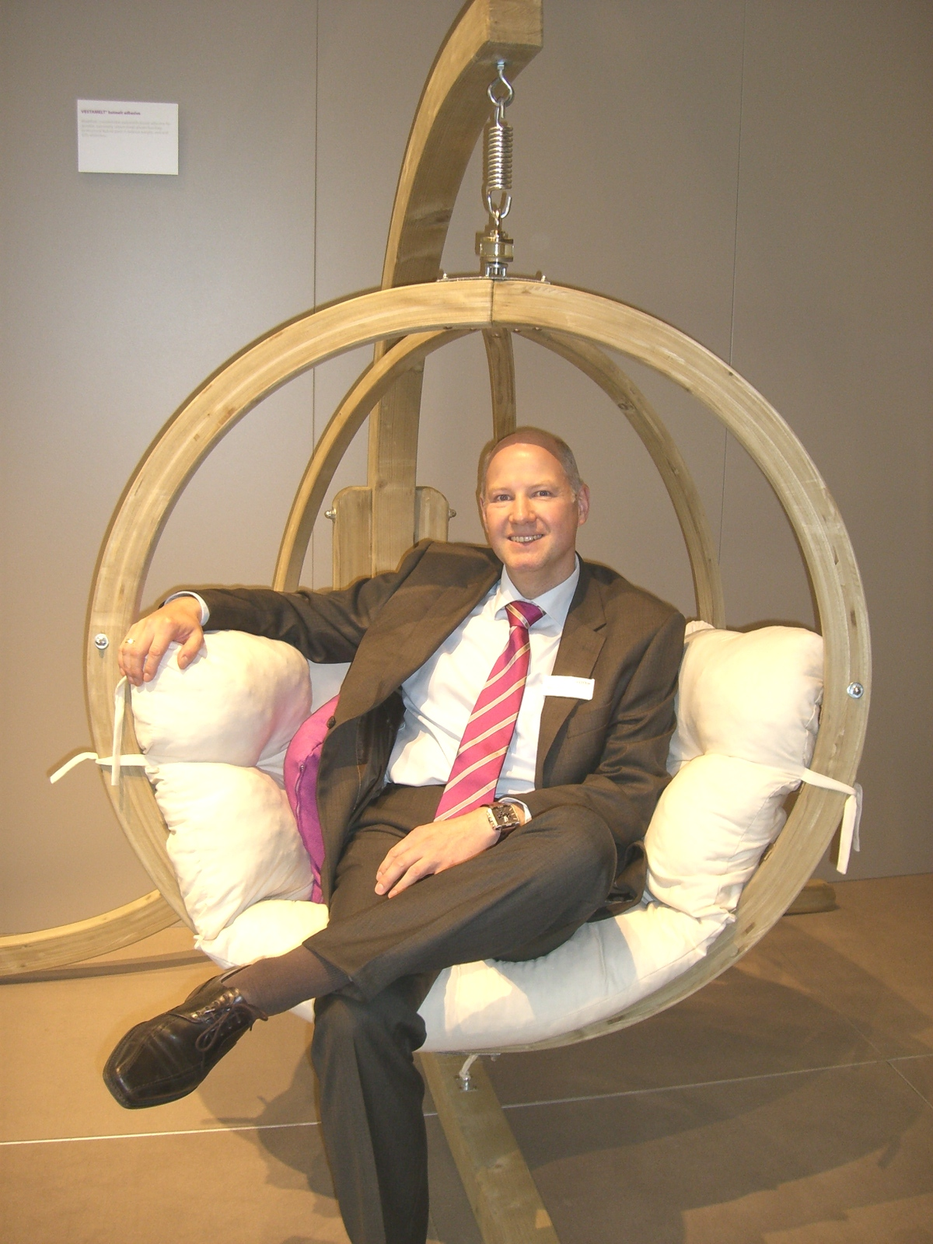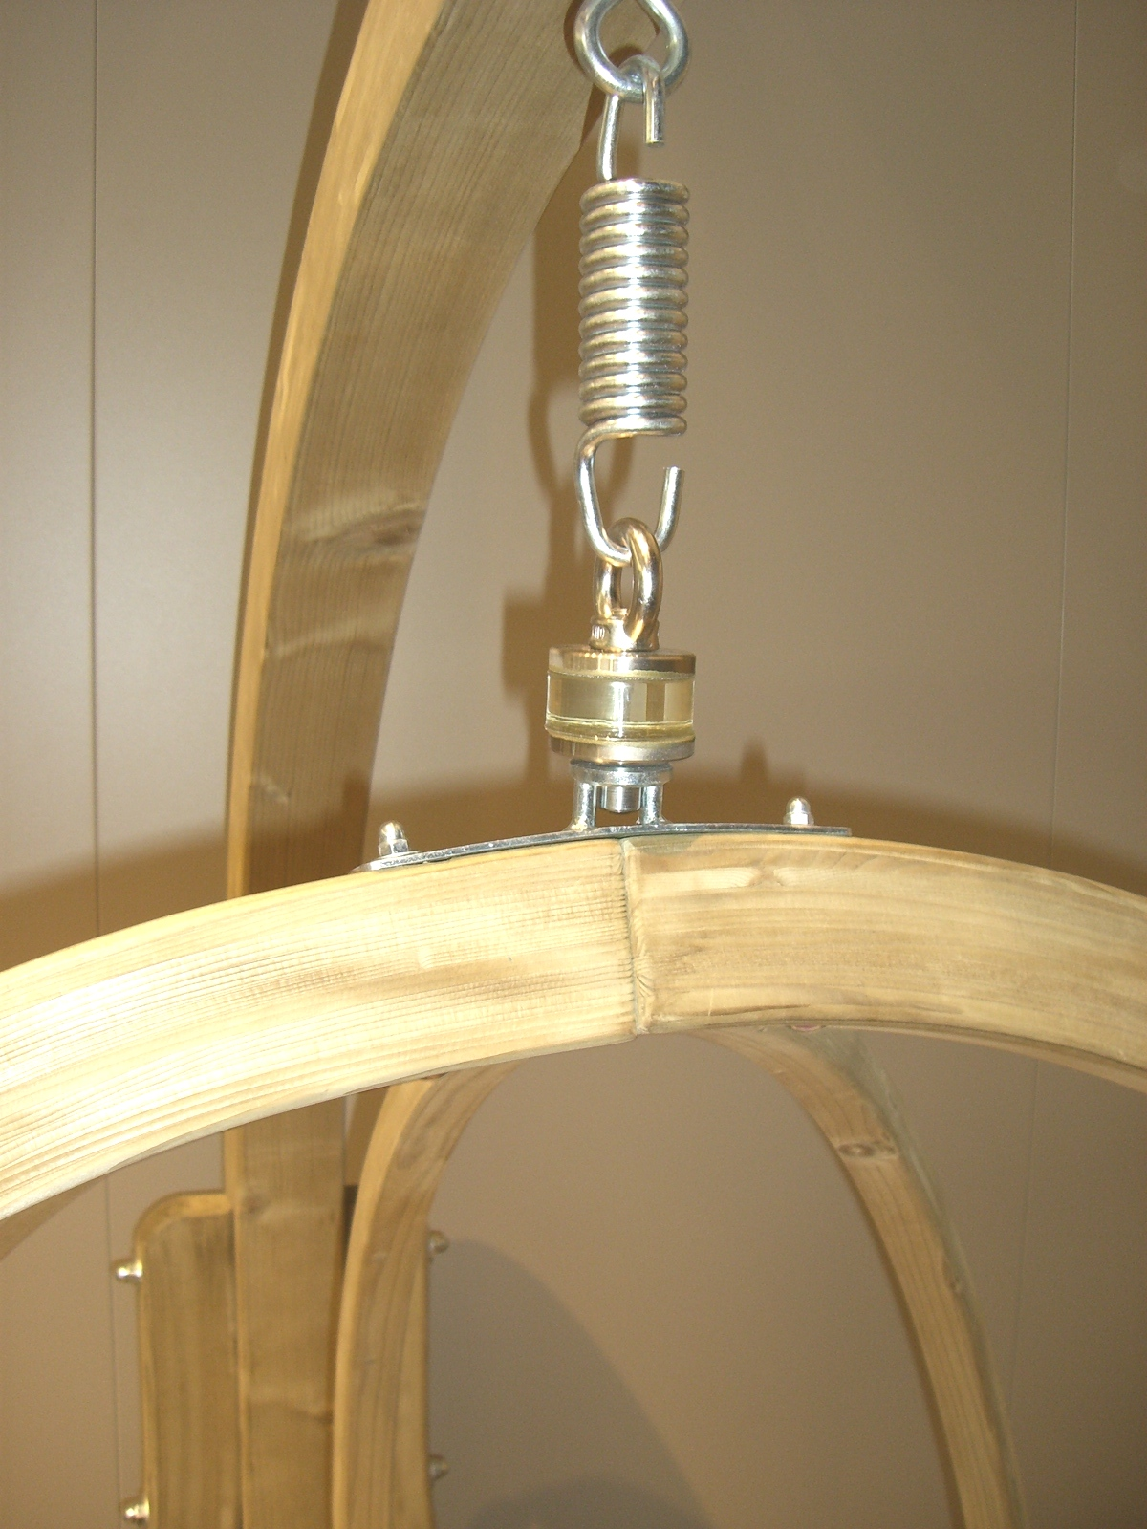

Exceptional solutions in plastics are no exception for us
Working together with its customers and partners, Evonik develops products and system solutions for and with plastics. We thus have a range of services that satisfies market and application requirements.

Evonik is present in all major growth markets around the globe. Its customized products and solutions include raw materials, sophisticated additives and paints, engineering plastics, high-performance polymers, and semi-finished products. They are virtually exactly what is needed for tomorrow’s efficient, sustainable, and environmentally friendly ideas.

About Evonik
Evonik Industries is the creative industrial group from Germany. In our core business of specialty chemicals, we are a global leader. In addition, Evonik is an expert in power generation from hard coal and renewable energies, and one of the largest private residential real estate companies in Germany. Our company’s performance is shaped by creativity, specialization, continuous self-renewal, and reliability.

Evonik is active in over 100 countries around the world. In its fiscal year 2009 about 39,000 employees generated sales of about €13.1 billion and an operating profit (EBITDA) of about €2.0 billion.

Disclaimer
In so far as forecasts or expectations are expressed in this press release or where our statements concern the future, these forecasts, expectations or statements may involve known or unknown risks and uncertainties. Actual results or developments may vary, depending on changes in the operating environment. Neither Evonik Industries AG nor its group companies assume an obligation to update the forecasts, expectations or statements contained in this release.

