November 05, 2015

Technical Media Contact
Ursula Keil
High Performance Polymers
Phone +49 2365-49-9878
Fax +49 2365-49-809878
ursula.keil@evonik.com

Evonik Resource Efficiency GmbH
Rellinghauser Straße 1-11
45128 Essen
Germany
Phone +49 201 177-01
Fax +49 201 177-3475
www.evonik.com

Supervisory Board
Dr. Ralph Sven Kaufmann, Chairman
Management Board
Dr. Claus Rettig, Chairman
Dr. Johannes Ohmer,
Simone Hildmann,
Alexandra Schwarz

Registered Office: Essen
Register Court: Essen Local Court
Commercial Registry B 25783
VAT ID no. DE 815528487
Polyphthalamide VESTAMID® HTplus and HNBR component for automotive cooling circuit manufactured with plastic-rubber technology

Cooling circuit parts installed by renowned automotive manufacturers consist of a direct composite comprising the special polyphthalamide (PPA) VESTAMID® HTplus R1033 by Resource Efficiency Segment of Evonik, Essen, and a newly developed HNBR elastomer by KACO GmbH & Co. KG, Heilbronn. The composite is generated with the patented plastic-rubber technology.

This technology enables the firm bond of a component's plastic and rubber parts without pretreatment. Moreover, the process does not require the application of an adhesion promoter. The plastic material, such as VESTAMID® HTplus R1033, must be specifically formulated for this purpose. The newly developed HNBR elastomer by KACO shows outstanding initial adhesion. "We decided in favor of this production process because the direct composites prevent undefined modifications in the component's interior, which may result from applying a bonding agent. Given the low tolerance ranges we work with, that would be unacceptable," says Marcus Teller, product developer of sealant parts at KACO, about the use of VESTAMID® HTplus R1033.

Conversely, this implies that the plastic part cannot change its dimensions when exposed to various cooling media – the glycol-water mixtures used by different automotive manufacturers. The bond with HNBR also must remain stable when the part is in contact with various media or subjected to temperature extremes. "This is ensured by the high chemical resistance of PPA as well as the special properties of VESTAMID® HTplus R1033 for composite bonding," says Frank Lorenz, who is responsible for automotive product applications at Evonik. The plastic part remains dimensionally stable even in the elastomer vulcanization process, which allows for trouble-free component function for a million transmission cycles depending on the transvers path.

Caption:
The interior component made of VESTAMID® HTplus R1033 can be firmly bonded to the exterior HNBR elastomer without the use of an adhesion promoter, resulting in high-precision components for automotive cooling circuits.
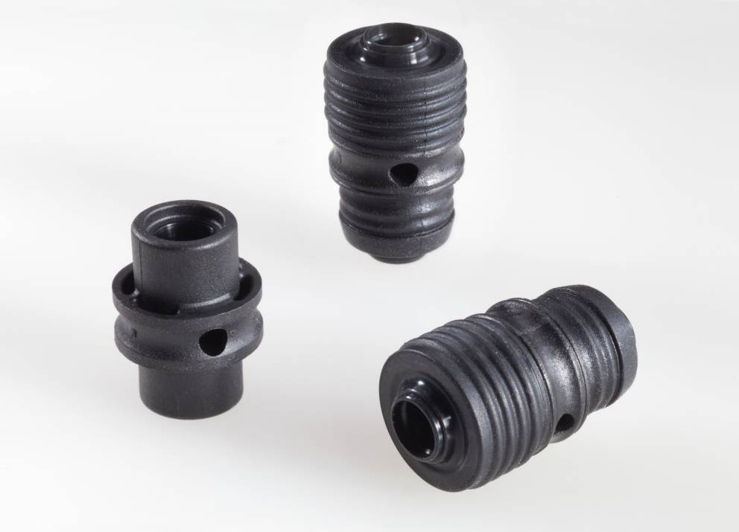

About Resource Efficiency
The Resource Efficiency segment is led by Evonik Resource Efficiency GmbH and supplies high performance materials for environmentally friendly as well as energy-efficient systems to the automotive, paints & coatings, adhesives, construction, and many other industries. This segment employed about 7,800 employees, and generated sales of around €4 billion in 2014.

About Evonik
Evonik, the creative industrial group from Germany, is one of the world leaders in specialty chemicals, operating in the Nutrition & Care, Resource Efficiency and Performance Materials segments. The company benefits from its innovative prowess and integrated technology platforms. In 2014 more than 33,000 employees generated sales of around €12.9 billion and an operating profit (adjusted EBITDA) of about €1.9 billion.

Disclaimer
In so far as forecasts or expectations are expressed in this press release or where our statements concern the future, these forecasts, expectations or statements may involve known or unknown risks and uncertainties. Actual results or developments may vary, depending on changes in the operating environment. Neither Evonik Industries AG nor its group companies assume an obligation to update the forecasts, expectations or statements contained in this release.

