November 19, 2015

Specialized Press Contact
Ursula Keil
High Performance Polymers
Phone +49 2365-49-9878
Fax +49 2365-49-809878
ursula.keil@evonik.com

Evonik Resource Efficiency GmbH
Rellinghauser Strasse 1-11
45128 Essen
Germany
Phone +49 201 177-01
Fax +49 201 177-3475
www.evonik.com

Supervisory Board
Dr. Ralph Sven Kaufmann, Chairman
Management Board
Dr. Claus Rettig, Chairman
Dr. Johannes Ohmer,
Simone Hildmann,
Alexandra Schwarz

Registered Office: Essen
Register Court: Essen Local Court
Commercial Registry B 25783
VAT ID no. DE 815528487
Crucial for dynamic stability control
VESTAMID® L1930 gear wheels for steering angle sensors

Driving in the dark, on a bend, or on a wet road—modern vehicles are usually equipped with dynamic stability control to keep them in lane in situations such as these. This electronically controlled driver assistance system requires an angle sensor with an important safety function to be built into the steering column. This is why Valeo Schalter und Sensoren GmbH, headquartered in Bietigheim-Bissingen (Germany) opted for VESTAMID® L1930 polyamide 12 from the Resource Efficiency Segment of Evonik, Essen, as the material for the gear drive of the steering angle sensor.

The steering angle sensor measures the steering angle of the steering wheel and continuously indicates to the dynamic stability control system—also known as the electronic stability control, or ESC—the direction in which the driver wants to go. The ESC compares the driver’s intended course with the vehicle’s actual direction and makes the necessary adjustments by targeted braking of individual wheels. This should prevent acceleration of the vehicle on bends, for example, and ensure that the driver can retain control of the vehicle.

The sensor is mounted in the steering column. A rotor consisting of a large gear wheel is actuated by the steering column and drives two smaller gear wheels with different numbers of teeth (on the Nonius principle). The magnets embedded in the gear wheels allow detection of the rotational position of the gear wheels by means of Hall or MR angle sensors. The electrical information provided by the angle sensors thus allows calculation of the absolute steering angle. The materials used for the gear drive must satisfy stringent requirements to ensure high accuracy and ruggedness in the steering angle sensor and maintain the required angular accuracy.

VESTAMID® L1930 offers exactly these properties: As a polyamide 12 it is temperature-stable over a wide range, from -40°C to 125°C. Its properties change only very slightly with variations in ambient humidity; molded parts show almost no dimensional changes. It has extraordinarily high impact resistance and notched impact strength, even well below freezing point. It has good to very good resistance to oils and greases, fuels, hydraulic fluids, and salt solutions, making it ideal for automotive use. Its outstanding abrasion resistance and low sliding friction coefficient are essential qualities for the gear wheels of the steering angle sensor, and it also has noise- and vibration-damping properties.

VESTAMID® has been used in the automotive sector by well-known car makers for 50 years. Continued development has led to an increasingly large number of application areas, ranging from line systems through cable sheathing to the very smallest injection-molded parts.

Figure caption:
VESTAMID® L1930 gear wheels contribute to safer driving: They ensure an accurate measurement result, which is essential for dynamic stability control.

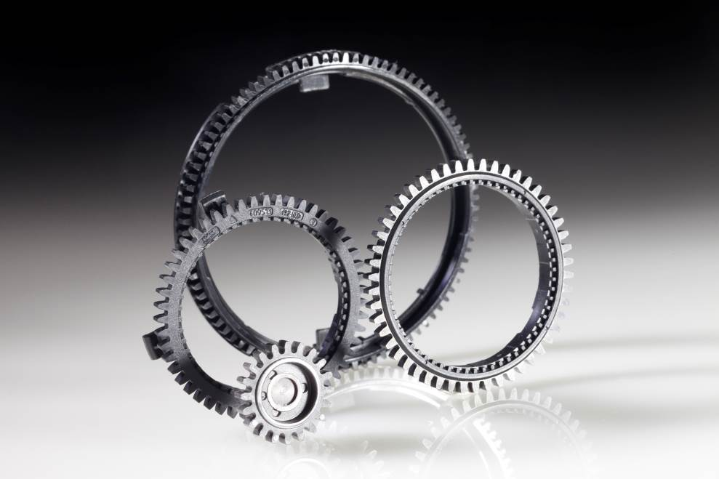

About Resource Efficiency
The Resource Efficiency segment is led by Evonik Resource Efficiency GmbH and supplies high performance materials for environmentally friendly as well as energy-efficient systems to the automotive, paints & coatings, adhesives, construction, and many other industries. This segment employed about 7,800 employees, and generated sales of around €4 billion in 2014.

About Evonik
Evonik, the creative industrial group from Germany, is one of the world leaders in specialty chemicals, operating in the Nutrition & Care, Resource Efficiency and Performance Materials segments. The company benefits from its innovative prowess and integrated technology platforms. In 2014 more than 33,000 employees generated sales of around €12.9 billion and an operating profit (adjusted EBITDA) of about €1.9 billion.

Disclaimer
In so far as forecasts or expectations are expressed in this press release or where our statements concern the future, these forecasts, expectations or statements may involve known or unknown risks and uncertainties. Actual results or developments may vary, depending on changes in the operating environment. Neither Evonik Industries AG nor its group companies assume an obligation to update the forecasts, expectations or statements contained in this release.

